The A10 Build

Todo’s 3

Inputs 4

Editing LUA files 4

OpenCockpits 4

IP Port Utilisation 7

A10 Device Numbers 8

Logic for Determining if Power is Applied 8

Mapping DCS Commands 8

Working with Magnetic Switches 9

C# Notes 10

Troubleshooting 11

Monitor Configuration 11

Screen numbers 11

Ensuring the CMSP is being updated when cockpit view is disabled 13

Configuring Switches 15

C# Joystick 16

The Simmeters Gauges 17

GPS Out 18

BNE-JOYSTICK-TESTER 19

Code Structure and code Flow 20

DCS-Command-Sender 21

CDU and SOIC Interface 22

Driving the OLEDs 24

Initialisation Sequence 25

Transmit Data to oled 25

Native LUA data 26

Preformatted data from bne-ocr-oled 26

The Arduino Sketch 26

PCB Design and Manufacturing 28

Making Physical Gauges 29

IP Addressing of Arduino Interfaces 30

Clock and Compass Logic 30

More To dos 32

Data Flows 37

Data Flows with Protocol and Ports 42

Devices 44

Stepper Motor for Compass and Clock 46

Stepper Motor with Vid 47

Joystick Input Card 48

PCB Layouts 49

V6 PCB – 49

Previous version 49

Order 3 50

Order 1 51

OLED128 QuickStart Guide 52

Connecting the OLED128 52

Alternative Connections 53

Note about cabling 56

SD CD (Card Detect) 56

Alternative MicroSD Connections 56

Installing the FTOLED Library 56

Uploading your first OLED Sketch 57

Exploring the Examples 58

Using the FTOLED Library 59

Snap Off Tabs 59

Mounting buttons and LEDs on the wings 59

Beware Burn-In 60

OverPros Joystick 60

# Todo’s

1. On start-up bne-dcs-soic-cmd-lineconverter should energise coils on magnetic switches this allows for the user to place the magnetic switches in the correct position before launching the sim. Values to set are:
   1. table.insert(soic_conv_flightData,"185=" .. soic_conv_mp:get_argument_value(185)) -- SAS Left Yaw
   2. table.insert(soic_conv_flightData,"186=" .. soic_conv_mp:get_argument_value(186)) -- SAS Right Yaw
   3. table.insert(soic_conv_flightData,"187=" .. soic_conv_mp:get_argument_value(187)) -- SAS Left Pitch
   4. table.insert(soic_conv_flightData,"188=" .. soic_conv_mp:get_argument_value(188)) -- SAS right Pitch
   5. **To be Verified as this is caution panel value** table.insert(soic_conv_flightData,"484=" .. soic_conv_mp:get_argument_value(484)) -- CAUTION LIGHT PANEL (ANTISKID)
   6. **To be Verified as this is caution panel value** table.insert(soic_conv_flightData,"516=" .. soic_conv_mp:get_argument_value(516)) -- CAUTION LIGHT PANEL (EAC)

# Post Windows and DCS upgrade Checklists

Initial fight in 1.5 before updating configs

|  |  |  |
| --- | --- | --- |
| Device | Comments |  |
|  |  |  |
| Simmeters Engine cluster | Fully operational | Ok |
| Simmeters VS, Alt, Airspeed | Fully Operational | Ok |
| Simmeters HIS, ADI | InOp – RDNIS listed in network adapters but set to DHCP  EADI – 10.0.1.2 EHIS 10.0.2.2/24 |  |
| Petes Gauges | G Meter, Clock, AoA, Compas, Fuel, LOX, Cabin Pressure - Fully Operational |  |
| PTs OLED | Centre MWS, and Jammer fully Op |  |
| Radio OLEDs | UHD, VHF FM, Volume appear to be ok |  |
| Radio OLEDs | ILS, TACAN, VHF AM, unable to test |  |
| SOIC Leds and fire handles | In Operational – device to script IDX mappings removed. 45-1, 46-0, 47-2 | ok |
|  |  |  |
| All Joysticks | Have unwanted analog axis mapped |  |
| CVP Joystick | 029E3460-F29C-11e4-8001-444553540000 – default config |  |
| Button Box Interface | 3E39D6E0-26DE-11e3-8001-444553540000 - default config |  |
| BR Sims F16 Rudder | 58D3DD0-A14F- 8001-8001-444553540000 - default config |  |
| CVP Joystick | 22A312D0F29C-11e4-8002-444553540000 - default config |  |
| Joy1 A0054 | 0F22F2210-9FF1-11e3-8004-444553540000 - default config |  |
| CVP Joystick | BD8C1150-EB28-11e4-8002-444553540000 - default config |  |
| Joy1 A0054 | 0F22F2210-9FF1-11e3-8003-444553540000 - default config |  |
| CVP Joystick | BD8C1150-EB28-11e4-8001-444553540000 - default config |  |
|  |  |  |
|  |  |  |
|  |  |  |
|  |  |  |
|  |  |  |
|  |  |  |
|  |  |  |
|  |  |  |
|  |  |  |
|  |  |  |
|  |  |  |
|  |  |  |
|  |  |  |
|  |  |  |
|  |  |  |
|  |  |  |
|  |  |  |
|  |  |  |

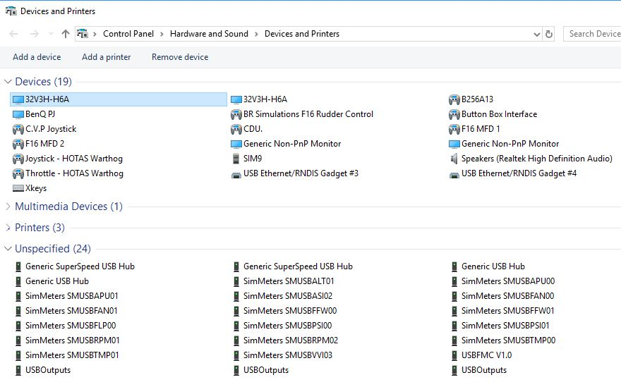Joysticks visible – All USB Devices appear to be visible

SOIC Devices Visible – but devices have not been linked

DCS Specific

Inputs – Joystick mappings – LUA file for each stick

* First cleared all button assignments – A10C – All – scrolled down to Gun – selected intersection for given stick and the hit Clear Category which removed all entries associated with that stick for A10 Sim – need to validate not impacted in other areas.
* A really nice feature is having the Sim synchronise switch positions on startup – under Options – Misc – Synchronise Cockput Controls with HOTAS controls at Mission Start
* Removed Axis assignment from all non-obvious controllers
* Found best place to test switch status is the free flight cold start mission.
* Note that the primary stick only appears to move forward and by until systems are started and then full range is available.
* Import to select Sim of interest to assign roles of stick.
* Very useful document put together by Hans-Werner Fassbender, ‘How to Edit Control Binding Files’
* With later versions of DCS, it is better to edit the default.lua for an aircraft, and then assign the new roles using the GUI. The default.lua is located under mods -> aircraft.

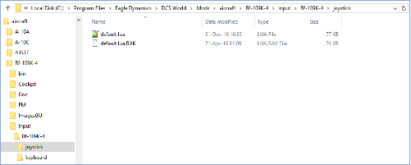

* When editing default.lua – you will need to have exited at least the mission (and possibly DCS) for changes to be effected. If you have modified a control, then it will need to be reassigned in the GUI (ie mapping is cleared when it is changed.
* To get possible values to assign use clickabledata.lua which has device IDs, still need to use table to find device number (there is a youtube video showing it working with names instead of numbers, but could get that to work on DCS 1.5). Commands for a device start at 3000 – so need to that 300 to command number.
* With later releases of DCS, a like a new format is used for inputs, instead of being a .lua it is .diff.lua. The older .lua file appears to being ignored

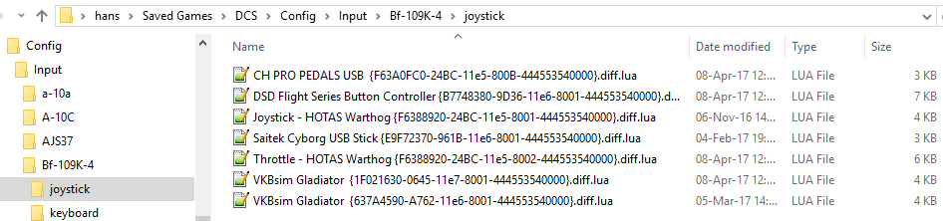

When using multi-position switches in addition to 1,0,-1, there are also controls with 1,0.5,0, when just use the first control number (eg Caopy Open,hold,close)

Using AntiCollision switch on lightning panel as test reference. Button 26

|  |  |
| --- | --- |
| Joy1 A0054 | 0F22F2210-9FF1-11e3-8004-444553540000 - default config |

CVP

BD8C1150-EB28-11e4-8002-444553540000 - default config

Radio Commands

CDU

Output gauges

No work was needed, both Simmeters and SIOC worked.

Monitors – screen layout

Multi-monitor didn’t play nicely. Options.lua is very helpful when trying to change screen. Options.lua is found in Saved Games – DCS – Config.

Generally will be working with lua files living in Program Files – Eagle Dynamics – DCS World – Config -Monitor Setup

Using Screen size of 4618 * 1848

Added GUI view in Curved Single Screen

It looks like the view ports are not using the older names enabled by Easy Monitor Configurator (EMC) eg ED_A10C_LEFT_MFCD (others prefixed by ED_A10C), removed prefixes and the two MFDs reappeared, CDU and RWR display are not displaying.

Looks like EMC is using Arcrafts directory not aircraft

Installed uMFCD – originally MS Defender stopped it operating, allowed operation – it overrides existing exports – so MFCDs stopped. uMFCD fails if not connected to the net – license validation failed.

Have issue with HUD disappearing when entering pit, it reappears afeter turning off bothAC Gen and battery switches. It also reppears if a button on UFC is press.

Dedcided to run and run with DCS 2.5, installing A10C and FC3.

Usng ovgme_1_7_4 to saved modifications out.

Lastly return change Trim hat back from view scroll to Trim

File Permissions

Removed Read-only and allowed users full control of file sin DCS directory.

Devices

# Inputs

The pit originally started using a combination of Leo Bodnar cards for Rotary inputs and the B256A13 card. With OverPro’s contribution, an Arduino based solution fits well. As with the B256A13, it is Matrix based, which means diodes are needed, but it does considerably reduce the amount of cables needed in the pit.

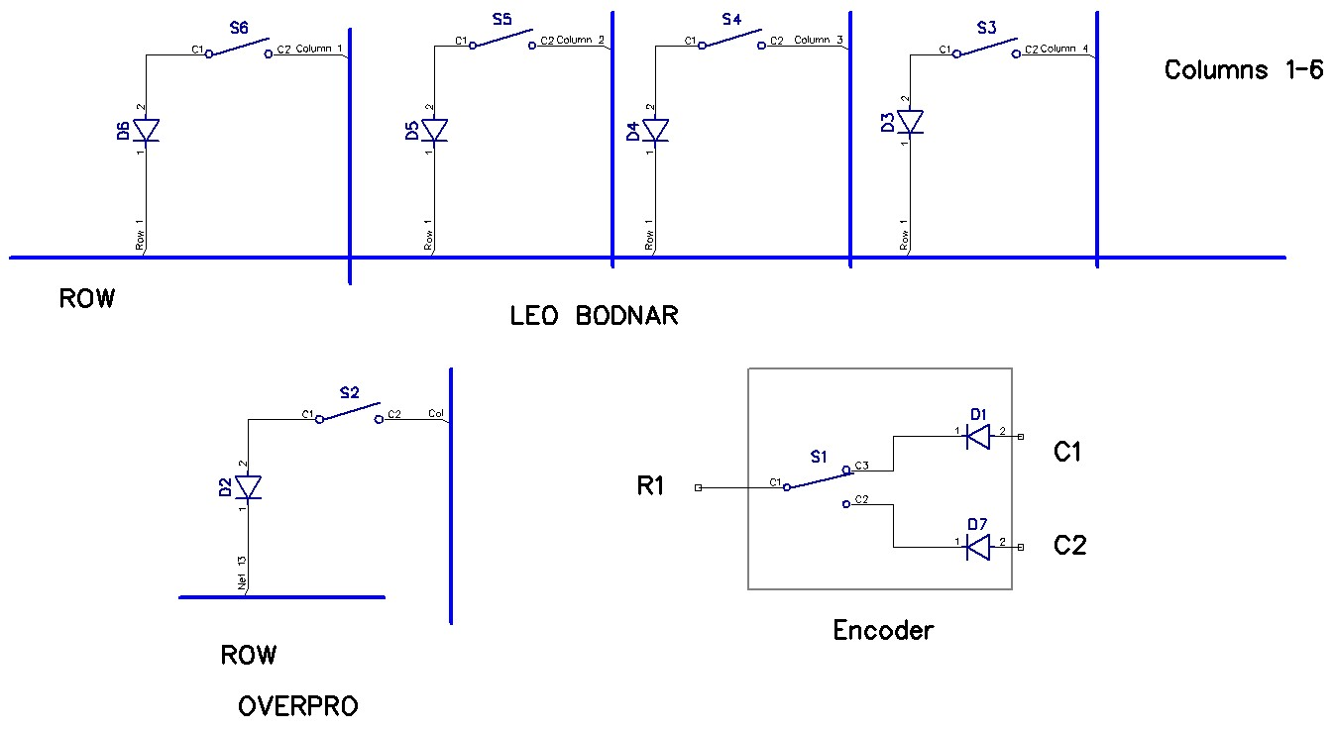

Despite that the Arduino code enables internal pullup resistors, ghosting was seen when certain patterns of switches where enabled. Ultimately addressed with 47K pull up resistors being added to the Columns bus.

# Editing LUA files

You can edit the LUA file while the sim is running, i.e. you do not have to fully exit and come back in. Even while in flight the lua files can be editing, but is a good idea pause the sim just to reduce the likelihood of a file lock.

# OpenCockpits

Open Cockpits (OC) hardware is both cost effective, and once you’ve got your head around it, very flexible, the biggest challenge is getting started.

To test the USB output card use test_outputs.exe, this is a simple to use GUI for turning outputs on/off. It can also be used to see what are the device numbers associated with each card. Note these device numbers are likely to change if you inserted them into a different USB port. If you are unsure which is which ground one of the analog inputs, the other inputs will jump around.

*For testing LHS is 169, RHS is 114*.

The modules generally communicate to the hardware via a SOIC Server that uses compiled scripts to map incoming variables from the simulator to OC hardware. The output module needs to be linked to script variables.

1. Start SOIC Server
2. If the OC card is not already plugged in, plug it in
3. You should see an entry in the devices box in the top right hand corner
4. Click the config devices button
5. If the device is not already configured you’ll see the card’s ‘Script Device IDX’ is not defined, and the Master Status is ‘not linked’ in the right hand window. To link, click the USBOutputs line on the left hand box, and the Master entry in the right hand box, then the link button.
6. Save and Exit.

*For testing Mapped 169 as Master (IDX=0) and 114 as IDX = 1*

If you are using multiple USB Output cards, one will be the Master, the second will be unlink. Click on the card whose IDX is ‘Not Defined’ and enter a script IDX in the center text box. Click ok and save.

*For testing – normally do not specify Device Number (Dispositivo?), assigned Device Number 1 to T/O Trim 191. Done by click Edit Script, Double Clicking on Var and assigning value. File Save, Close Window, click Reload.*

*Now go into IOCP Console, Connect, Log On. Set value of Var 191 to 1. Test switch holds position.*

*For final test, added another card, Device 164 in USB Outputs. Changed Device IDs, 169=0, 164=1, 114=2.*

Dimming USB Outputs

As two of the three USB Output cards are driving leds, they should be dimmable. The card driving Magnetic switches and relays should be a fixed output.

Here’s the sample script:

Var 0002, name dimmer, Link IOCARD_ANALOGIC, De

vice 1, Input 1, PosL 1, PosC 128, PosR 255

// potentiometer reading

{

&bright = &dimmer

}

Var 0003, name bright, Link IOCARD_DISPLAY, Device 1, Digit 1, Numbers 3 // dimmer at USB Outputs

The steps to create the script:

Go into Script Editor and create all the variables (basically assigning a name to an output or handle).

Once this is done click on the input value that will be used to set the outputs, and choose edit-> New Command. From there you create an assign of source var to destination variable. In the GUI the commands should appear under the input variable. Note – you need to ensure you have selected the input variable when adding the commands

*Var 0003, Link IOCARD_OUT, Device 1, Output 0  
  
Var 0004, name dimmer, Link IOCARD_ANALOGIC, Device 2, Input 0, PosL 1, PosC 128, PosR 255  
{  
  &bright = &dimmer      
  &bright2 = &dimmer      
}  
  
Var 0005, name bright, Link IOCARD_DISPLAY, Digit 1, Numbers 3  
  
Var 0006, name bright2, Link IOCARD_DISPLAY, Device 1, Digit 1, Numbers 3*

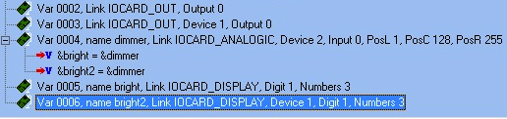

The Output Cards variables are mapped in the primary .ssi associated with the SOIC server. The variables associated with the LCD are maintained in a separate file, which is editing using IOClcd_config.exe.

For testing I was using a 16*2 LCD.

|  |  |  |  |  |  |  |  |  |  |  |  |  |  |  |  |
| --- | --- | --- | --- | --- | --- | --- | --- | --- | --- | --- | --- | --- | --- | --- | --- |
| 143 | 143 | 144 | . | 145 | 146 | 146 |  |  |  |  | 8020 | 8021 | 8022 | - | 8023 |
| 157 | 157 | 158 | . | 159 | 160 | 160 |  |  |  | 8010 | 8010 | 8010 | . | 8011 | 8011 |

|  |  |  |  |  |  |
| --- | --- | --- | --- | --- | --- |
| VHF AM |  |  |  |  | TACAN |
| VHF FM |  |  |  | ILS | |

FMC

The FMC requires a little configuration. On the test PC, under SOIC devices it reports

IDX=13 – USBFMCV1.0 – Device = 101

Unlink config devices (this is real important as normally devices are linked)

USBFMC V1.0 – 101 Master – 13 1 (#cards) <> Master 13 1 LINKED – no desc.

In the bottom Left Hand Side box is Device defs in script)

IDX(13) IOCARD_KEYS 0 /Keys 2

If you then go to IOCP Console (connect logon), you’ll see key presses being recorded

When adding to a second test computer went to config window, highlight FMC on LHS, , entered Scripted IDX of 13 on mid lower dialog box. Did link it on the RHS as this causes a duplicate message.

Added the following to the script (after doing txt export)

Var 0001, name keys2, Link IOCARD_KEYS, Device 13

# IP Port Utilisation

|  |  |  |  |  |
| --- | --- | --- | --- | --- |
| Application | Client/Server | TCP/UDP | Port | Partner Applications |
|  |  |  |  |  |
| SOIC Server | Server | TCP | 8092 | IO Card LCD, |
| IO Card LCD | Client | TCP | 8092 | SOIC Server |
| SOIC_Conv | Client | TCP | 8092 | SOIC Server |
| SOIC_Conv | Server | UDP | 7777 | DCS World – Receives comma delimited data from DCS |
| SOIC_Conv | Server? | UDP | 7779 | DCS World? |
| SOIC_Conv | Client | UDP | 7780 | DCS World  CDU Keystrokes send to DCS |
| DCS World | Server | UDP | 7780 | SOIC_Conv – Receives CDU Keystrokes from SOIC_Conv |
| Arduino Display | Server | UDP | 7781 |  |
| GPS Out | Server | UDP | 7782 | Receives UDP packets from BeforeNextFrame and reformats to serial with checksum for GPS |
| Simmeters | Server | UDP | 6061 | DCS World – Receives comma delimited data from DCS |

# A10 Device Numbers

|  |  |
| --- | --- |
| Device | Device No |
| CMSC | 8 |
| CMSP | 7 |
| TACAN | 51 |
| ILS | 53 |
| UHF | 54 |
| VHF AM | 55 |
| VHF FM | 56 |
| Intercom | 58 |

# Logic for Determining if Power is Applied

For some of the radios you can check the is_on method.

The intercom, ILS and TACAN do not support this so used logic which checked to see if any of the follow Battery or either of the Alternator switches are on.

# Mapping DCS Commands

For the A10C the primary configuration files are found in c:\program files\eagle dynamics\dcs world\mods\aircrafts\A-10c\cockput\scripts.

To determine what is the number of the device to export, clickabledata.lua, and search for system you are interested in, for example SAS:

--STABILITY AUGMENTATION SYSTEM PANEL

elements["PTR-SASP-YAW-SASENGAGE-L"] = electrically_held_switch(_("Yaw SAS Engage left"), devices.AUTOPILOT, device_commands.Button_3, device_commands.Button_4, **185**)

Here 185 is the reference that would be used in export.lua.

If you want to set a value through the lua interface a little more hunting is needed. Generally once you have found the number of the device, you’ll add a c in front of it to send the command, eg the CDU Device Number is 9, so the command string becomes c9. Additionally command inputs start at 3000, so even though a button 4, the command will be 3004.

So first the easy stuff, in command_defs is the bulk of basic commands that can be used to control the plane and views. Stuff such as PlaneGear, MasterArm.

If something more explicit is needed clickabledata.lua is the first point of reference. Lets try and set the SAS Yaw Left switch. Searching for SAS gives us the box we see above.

--STABILITY AUGMENTATION SYSTEM PANEL

elements["PTR-SASP-YAW-SASENGAGE-L"] = electrically_held_switch(_("Yaw SAS Engage left"), **devices.AUTOPILOT, device_commands.Button_3, device_commands.Button_4**, 185)

This tells us the switch is associated with the AutoPilot, and the command buttons are 3 and 4. At this point we don’t have the device number. This can be found by going to devices.lua. Note that there is SAS device, but autopilot is used here.

devices["ENGINE_SYSTEM"] = counter()--37

devices["AUTOPILOT"] = counter()--38

devices["CPT_MECH"] = counter()--39

So the Device Number is 38.

Observations with SAS Panel

3003 – 1.0 Toggles switch state in pit

3003 – 0.0 Always turns switch off

3004 – 0.0 Switch state appears to remain unchanged

3004 – 1.0 Always turns switch on

A list of command that can be controlled is found in command_defs.lua, but that isn’t complete, clickabledata.lua is pretty complete, and devices.lua

It looks like the you also need to map to a specific device and then send commands starting at 3000.

To find a value to

# Working with Magnetic Switches

There are a least six magnetic switch in the A10C, four on the SAS Panel, Anti-Skid, and EAC on the Throttle (and possibly one for the anti-collision lights)

When sending commands with LUA, they generally imply that the ‘switch’ being controlled is ‘held’ in the last position the LUA command was sent.

This presents a challenge, if the simulation believes someone is ‘holding’ the switch on, it is unable to automatically release the switch, which means magnetic switches never get to return automatically to the off position.

To add to the challenge, there isn’t a default command with the GUI that makes to ‘turning on’ one of the four SAS channels. There is however a command to toggle each of the channels.

The final approach chosen involves activating the magnetic coils before entering the sim. This enables you to set the correct physical switch state before starting the sim. The coils will always be activated as part of soic-cmd-line-converter start-up, it is then up to the operator to know the desired switch state before starting the sim.

The code associated with the switch is found in the config\input\A-10C\joystick folder, with the expanded name of the joystick (e.g. Joy1 Ձ0013 {EC9B68B0-9BC4-11e3-8002-444553540000}.lua)

*{combos = {{key = "JOY_BTN121"}}, down = iCommandPlanePitchSASEngageL, name = "Pitch SAS engage Left", category = "Stability Augmentation System"},*

*{combos = {{key = "JOY_BTN106"}}, down = iCommandPlanePitchSASEngageR, name = "Pitch SAS engage Right", category = "Stability Augmentation System"},*

The above can either be selected by the gui or manually edited, note this only toggles the state as opposed to explicitly setting state. So unless something else is done, if you start the sim with the switch not in the correct state, it will always be incorrect.

This is addressed by using the bne-dcs-joystick-to-cmd program to monitor the state of the switch as well (it opens the joystick in a cooperative background mode, enabling the program to monitor joystick status irrespective of whether it has focus or not. When the switch is released/open the LUA command associated with the device/switch is set to 0. This means, at worst, a single toggle of the switch will synchronise the state of the physical switch with that of the simulator.

Operation

1. soic-cmd-line-converter starts, connects to SOIC server, and then sends the string to enable coils for the SAS channels and Anti-skid. Currently EAC just uses the switch on the Thrustmaster throttle
2. Operator manually sets the physical switch position

## C# Notes

User settings are saved in Users\Admin\AppData\Local\DCS_Command_Sender

# Troubleshooting

If you pass a variable with text or decimal points, the SOIC server will disconnect the connection.

When editing LUA files in DCS it is strongly recommended to use Notepad++ to ensure no corrupt characters end up in the file.

# Monitor Configuration

From <http://forums.eagle.ru/showthread.php?t=68815>

Saving cockpit angles  
  
1. Toggle snap views: RCTL KP0  
2. Choose the snap view you want to change and press that key: e.g. KP5  
3. Untoggle snap views: RCTL KP0  
4. Move your view to desired position  
5. Save cockpit angles: RALT KP0  
6. Press the key of the snap view you chose before: KP5  
  
Voila! RCTL KP0 and then KP5 should now give you the changed view you wanted. You can also, as you say above, now look in your SnapViews.lua file and see the values in [11][6] and save them for future reference.

## Screen numbers

|  |  |  |  |
| --- | --- | --- | --- |
| Role | No | Width | Height |
| MAIN SCREEN | 1 | 3840 | 1024 |
| RWR | 5 | 1024 | 768 |
| LEFT MFD | 3 | 1280 | 720 |
| RIGHT MFD | 2 | 1280 | 720 |
| CDU | 4 | 1024 | 768 |

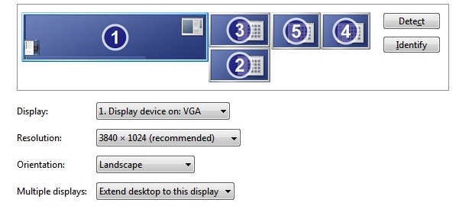

DCS when using MFDs needs the resolution on the main menu to be set to a resolution that encompasses all of the screens that will be displaying output from DCS.

So if you have a main screen of 1024*768, and two MFDs 1280*720, then the total resolution for DCS needs to be set to 3584*768. This is configured in ‘options.lua’.

Generally it is easier to have the main display in the top left.

MFD Display Positions based on main screen of 1024*768

|  |  |
| --- | --- |
| Left Hand |  |
| Top | 49 |
| Bottom | 656 |
| LHS | 1441 |
| RHS | 2228 |
| Right Hand |  |
| Top | 42 |
| Bottom | 652 |
| LHS | 2374 |
| RHS | 3159 |
|  |  |

To create a custom monitor setup, go to Prog Files> Eagle Dynamics>DCS World > Config > Monitor Setup

Normally easiest just to start by copying an existing one. Don’t forget to update the name at the top of the file (this is what is displayed in the list of choices in DCS), as well as the file name itself.

Exporting the CDU involves steps over and above what is needed for MFD.

Thread here

<http://forums.eagle.ru/showthread.php?t=105584>

The cdu_init.lua attached to the thread works, although work is needed to make it fit.

The working screen file for CDU (note the CDU tag is referenced from cdu_init.lua

Viewports =

*{*

*Center =*

*{*

*x = 0;*

*y = 0;*

*width = 1920;*

*height = 1080;*

*viewDx = 0;*

*viewDy = 0;*

*aspect = screen.aspect / 2;*

*}*

*}*

*CDU =*

*{*

*x = 1940;*

*y = 60;*

*width = 800;*

*height = 520;*

*}*

*UIMainView = Viewports.Center*

## Ensuring the CMSP is being updated when cockpit view is disabled

Discovered that the CMSP and CMSC only update when the cockpit is being display. Ian provided the fix[1]. By exporting the CMSP and CSMC indicators to another viewport, they always be rendered (and the data will also be updated). The viewports can be 1x1 pixels in size (0x0 did not work for Ian). You can place these at a location where they won’t be displayed.

To make the ED_A10C_CMSP viewport available, append the following two lines to mods/aircraft/A-10C/Cockpit/Scripts/CMSP/indicator/CMSP_init.lua:

Code:

|  |
| --- |
| dofile(LockOn_Options.common_script_path.."ViewportHandling.lua")  try_find_assigned_viewport("ED_A10C_CMSP") |

And then repeat for CSMC.

And then update the monitor file.

Code:

|  |
| --- |
| ED_A10C_CMSP =  {  x = -50;  y = 0;  width = 20;  height = 20;  } |

The complete file - Pit + CDU (on RHS).lua

|  |
| --- |
| _ = function(p) return p; end;  name = _('PIT + CDU (RHS)');  Description = 'Left MFCD on the right and camera on the center'  Viewports =  {  Center =  {  x = 0;  y = 0;  width = 3840;  height = 1024;  viewDx = 0;  viewDy = 0;  aspect = screen.aspect;  }  }  ED_A10C_CMSP =  {  x = 1;  y = 1026;  width = 1;  height = 1;  }  ED_A10C_CMSC =  {  x = 1;  y = 1026;  width = 1;  height = 1;  }  ED_A10C_LEFT_MFCD =  {  x = 4230;  y = 46;  width = 848;  height = 644;  }  ED_A10C_RIGHT_MFCD =  {  x = 3915;  y = 762;  width = 863;  height = 640;  }  ED_A10C_RWR =  {  x = 5292;  y = 0;  width = 808;  height = 808;  }  ED_A10C_CDU =  {  x = 6158;  y = 21;  width = 1013;  height = 744;  }  UIMainView = Viewports.Center |

Default Views ofr Aircraft

"Num/ - RCtrl - RShift" Cockpit Camera Move Back   
"Num5" Cockpit Camera Move Center  
"Num2 - RCtrl - RShift" Cockpit Camera Move Down  
"Num* - RCtrl - RShift" Cockpit Camera Move Forward  
"Num8 - RCtrl - RShift" Cockpit Camera Move Up  
"Num8" Turn Cockpit Camera Up  
"Num2" Turn Cockpit Camera Down  
"Num/" FOV- aka Zoom-in  
"Num*" FOV+ aka Zoom-out  
"NumEnter" Default FOV aka Zoom  
  
Once you are satisfied , after using above key-commands,   
just use following key-command to save this view as default:  
  
"RAlt+Num0" Save current Cockpit view as default for this vehicle.

# Configuring Switches

Customisations – currently have re-tasked the Mic stick on the throttle to be the trim.

Switches –

DCS lists all joysticks in the config screen, and allows you to assign the same action to multiple switches. As switch can only have a single action associated to it via the gui.

The config file can be modified to provide an action when the switch is released, this is needed for three position switches such as Master Arm.

Before:

[243] =  
{  
["combos"] =  
{  
[1] =  
{  
["key"] = "JOY_BTN19",  
["reformers"] =  
{  
}, -- end of ["reformers"]  
}, -- end of [1]  
}, -- end of ["combos"]  
["name"] = "APU T-Handle Fire Extinguisher",  
["category"] = "Fire Extinguishers System",  
["down"] = 922,  
}, -- end of [243]

After

[243] =  
{  
["combos"] =  
{  
[1] =  
{  
["key"] = "JOY_BTN19",  
["reformers"] =  
{  
}, -- end of ["reformers"]  
}, -- end of [1]  
}, -- end of ["combos"]  
["name"] = "APU T-Handle Fire Extinguisher",  
["category"] = "Fire Extinguishers System",  
["down"] = 922,

**[‘up’] = 934**,  
}, -- end of [243]

There is a black art involved in finding what number matches what action. The only way I’ve fond is to look through the .lua file looking for the action, which has another number, and then look at the code association with down.

## C# Joystick

SlimDX simplifies reading a joystick. Add reference to SlimDX to project, browse to c:\program files(x86)\Slim DX\ SDK (Jan 2012)\bin\net40\x64\SlimDX.dll

The SDK must be installed to compile the code, when running the code only the SLimDX runtimes need to be installed.

## The Simmeters Gauges

Found an interesting issue with USB devices on my newest motherboard. Was getting the yellow exclamation marks in the Drivers and Printers panel, when you looked in device manager it said the device couldn’t start. This was not limited to gauges but even my trusty old set of pedals. Thought it may have been power related but still had the same issue after adding another hub. Ultimately resolved it by going to old computer and retrying it, where everything worked. Ultimately found that the old computer had two USB controllers (2.0 and 3.0) whereas the new computer had a single controller, so it looks like it is running out of something like USB IDs (even thought should be able to support 127 per controller).

Also ran into another issue with having all engine cluster gauges off a single Manhanattan hub. The concurrent zero action when workspace is started hammers the power supply causing the some of the gauges to hang.

Currently the Altimeter, VSI, and Airspeed don’t auto-zero. This means they must be manually zeroed after workspace is started. This in part is addressed by adding the following code in the export.lua

Use a batch file to start workspace, that way you can see what has registered.

The ESHI, EADI, and RWR all use RNDIS drivers. Unlike the other gauges, these gauges need a driver installed, which you manually select, Microsoft Corporate RemoteNDIS. It is sensitive to the USB port, so if you move the hub or port then the driver will need to be reinstalled.

Once the driver is installed a new NIC will be appear in network settings. If this is the finally USB location rename it to something meaningful. Then manually specify the IP address of the NIC and its subnet mask, do not accept the default for 10.0.0.0 network that is 255.0.0.0, instead use 255.255.255.0. The NICs IP address is not that of the gauge, it is the first address of the subnet, and it appears as though the gauges are always the .2 of the subnet.

**The config files points to the 0.1 address, the NIC (rdnis) is 0.2**

The gauges will briefly display a Linux like boot-up and then display in-op. As soon as Workspace starts the gauge should display correctly. The gauges are pretty smart, in that Workspace generates the entire picture to be display, and then throws it at the screen, which should mean the screen is flexible.

## GPS Out

Previously, the interface between the game (F4/FSX/LOMAC), had been a single customized stack per game written in Visual Basic. Given the bulk of the work was in generating the correct NEMA sentences a new approach has been developed for the A10. This time the NEMA interface stands separate from the individual game, waiting for comma limited values from the game to be delivered over UDP.

As A10C LUA scripting enables you to send UDP packets directly to another process, an intermediate filer is not needed.

The LUA script is broken into two parts, the declaration, and then a per frame data delivery. No shutdown code is needed as such, as the code is connectionless. These pieces of script will normally live in soic_conv_ExportStart.lua and soic_conv_BeforeNextFrame.lua.

**Initialisation Code**

*gps_export_port = 7782*

*gps_export_host = "127.0.0.1"*

*gps_export_socket = require("socket")*

*gps_export_con = socket.try(gps_export_socket.udp())*

*gps_export_socket.try(gps_export_con:settimeout(.001))*

*gps_export_socket.try(gps_export_con:setpeername(gps_export_host,gps_export_port))*

**Export before next frame**

*table.insert(gps_export_flightData,"Latitude="..LoGetSelfData().LatLongAlt.Lat) -- LATITUDE*

*table.insert(gps_export_flightData,"Longitude="..LoGetSelfData().LatLongAlt.Long) -- LONGITUDE*

*table.insert(gps_export_flightData,"Altitude="..LoGetAltitudeAboveSeaLevel()) -- ALTITUDE SEA LEVEL(MTS TO FT)*

*table.insert(gps_export_flightData,"Airspeed="..LoGetTrueAirSpeed() * 1.94) -- TRUE AIRSPEED (M/S TO KNOTS)*

*table.insert(gps_export_flightData,"Heading="..LoGetSelfData().Heading * 57.3) -- HEADING (RAD TO DEG)*

*for gps_export_i = 1, #gps_export_flightData do gps_export_packet = gps_export_packet .. gps_export_flightData[gps_export_i] .. ":" end*

*gps_export_socket.try(gps_export_con:send(gps_export_packet))*

The program opens a COM4, with a speed of 19.2kbps. COM4 was used as that was available in VMWARE. Currently code must to edited to change the port.

GPS Program Flow

1. Open serial port
2. Start UDP receive thread which blocks until a UDP packet is received from DCS, the byte array is then converted to a string ‘returndata’
3. ParseUDPString, splits the received string at “:” points, this creates an array of attribute=value pairs. For each pair it is split at the inner delimiter “=”, the first result is then used to select the correct statement. In turn this drives the second case statement, which updates the appropriate global variable. Note that the output to gps is independent of the rate of UDP packets from DCS.
4. The first timer runs every 500mS (probably need to reduce this to every 250mS). It assembles the output string, appends a checksum and then sends out the serial port. The references to f4 variables are due to the code being largely based on VB code used with falcon 4.
5. A second timer runs that updates the status label every 100mS.

The checksum code is based on a block of code found on the web.

private static string getChecksum(string sentence)

{

//Start with first Item

int checksum = Convert.ToByte(sentence[sentence.IndexOf('$') + 1]);

// Loop through all chars to get a checksum

for (int i = sentence.IndexOf('$') + 2; i < sentence.IndexOf('*'); i++)

{

// No. XOR the checksum with this character's value

checksum ^= Convert.ToByte(sentence[i]);

}

// Return the checksum formatted as a two-character hexadecimal

return checksum.ToString("X2");

}

## BNE-JOYSTICK-TESTER

This code originally monitored a single joystick. In March 2014 the concurrent monitoring of multiple sticks was added to simplify testing with the Brydling card. As the Brydling card as presents itself as two independent Joysticks to the OS, testing all switches in the pit required you to know which switch was connected to which logically joystick.

Operation

1. Ensure Joysticks are connected to the PC before starting the program.
2. The UI lists all closed switches from all Joysticks
3. When a new button is pressed, the display pauses briefly with the new button and the number of the button is read out.

This code also forms the basis of the BNE-DCS-CMD-SENDER (bne-dcs-joystick-to-command) that monitors switch state and sends an LUA string should a configured switch can to a position that has a command associated with it.

To simplify the code, the SlimDX libraries are using, this means:

1. The SlimDX runtime must be installed on computers where the program needs to run
2. The SlimDX SDK must be installed on Systems to compile the code
3. You may need to copy the SlimDX.dll to the debug directory

### Code Structure and code Flow

Major Variables

Joystick joystick;

JoystickState state = new JoystickState();

// List of all Joysticks connected to the system

List<SlimDX.DirectInput.Joystick> Sticks = new List<SlimDX.DirectInput.Joystick>();

// Holds button state of attached Joyasticks

List<bool[]> lButtonState = new List<bool[]>();

const int SizeOfArray = 300;

bool[] bSwitchState = new bool[SizeOfArray];

The list construct is used to hold the joysticks and their associated button state.

On initialisation, all attached Joysticks are enumerated, and added to the list. At the same time, an associated buttonstate list is instantiated. It holds an array whose size is determined by the constant SizeOfArray.

Sticks.Add(stick);

lButtonState.Add(localbool);

The Button state array is then explicitly cleared.

The Primary timer is then enabled.

Timer Event:

1. For each stick in the list, acquire, and then pass to the UpdateUI.
2. In UpdateUI the current state of buttons is collected
3. For each of the attached buttons, if the button is closed, the button number is appended to the text box, and check is then made to see if the state has changed since the last iteration. This is done by comparing the current button state against the multidimensional Button State List
   1. lButtonState[ListPointer][b] == false
4. Note that DCS uses a 1’s based array, whereas SlimDX uses a zero based array, so the value read is incremented by one to align with DCS.
5. The first time the sticks evaluated, new values are not called out.

## DCS-Command-Sender

This is largely based on the Joystick testing program. It first reads the configuration file, if the file doesn’t exist it creates a default one. The file is held in the users settings directory (C:\Users\pethomas\AppData\Local\DCS_Command_Sender\DCS_Command_Sender.exe_Url_xyenazhtgjbv4kt5h0pbfhajla0jlhoc\1.0.0.0)

The file name is user.config

It looks like:

*<?xml version="1.0" encoding="utf-8"?>*

*<configuration>*

*<userSettings>*

*<DCS_Command_Sender.Properties.Settings>*

*<setting name="Button_Description" serializeAs="String">*

*<value>Master 0,Mr 1,Button 2, Button 3, Button 4, Button 5</value>*

*</setting>*

*<setting name="Button_Up_Command" serializeAs="String">*

*<value>0,0,0,0,0,0</value>*

*</setting>*

*<setting name="Button_Down_Command" serializeAs="String">*

*<value>0,0,0,0,0,0</value>*

*</setting>*

*<setting name="Button_Number" serializeAs="String">*

*<value>0,0,0,0,0,0</value>*

*</setting>*

*<setting name="Button_Devices" serializeAs="String">*

*<value>0,0,0,0,0,0</value>*

*</setting>*

*<setting name="Stick_Names" serializeAs="String">*

*<value>0,0,0,0,0,0</value>*

*</setting>*

*<setting name="Stick_GUIDs" serializeAs="String">*

*<value>0,0,0,0,0,0</value>*

*</setting>*

*</DCS_Command_Sender.Properties.Settings>*

*</userSettings>*

*</configuration>*

As the config files is read, controls with attributes are dynamically added to the form, including actions associated with the controls. It is important, if manually editing the file to keep the number of values the same for each attribute.

As the code was originally developed just to monitor 6 buttons, the XML approach seemed to fit, if more than 6 buttons needed to be monitored consideration would be given to using a table like object with a small database in the back-end.

Once the buttons are initialised the code then monitors joystick state looking for changes. If a state change is seen (press or release) then array is walked looking to see if there is a matching Joystick/Button Combination. If this is found it is then sent to port 7780.

IPEndPoint CDUSender = new IPEndPoint(IPAddress.Loopback, 7780);

CDURemote = (EndPoint)(CDUSender);

soic_conv_BeforeNextFrame.lua

*cdu_receive_port = 7780*

*c_socket = require("socket")*

*cdu_socket = c_socket.udp()*

*cdu_socket:setsockname("*",7780)*

*cdu_socket:setoption('broadcast',true)*

*cdu_socket:settimeout(.001) -- set timeout for reading socket*

The values associated with switch state that are sent to bne-dcs-soic-cmd-lineconverter are:

*table.insert(soic_conv_flightData,"185=" .. soic_conv_mp:get_argument_value(185)) -- SAS Left Yaw*

*table.insert(soic_conv_flightData,"186=" .. soic_conv_mp:get_argument_value(186)) -- SAS Right Yaw*

*table.insert(soic_conv_flightData,"187=" .. soic_conv_mp:get_argument_value(187)) -- SAS Left Pitch*

*table.insert(soic_conv_flightData,"188=" .. soic_conv_mp:get_argument_value(188)) -- SAS right Pitch*

## CDU and SOIC Interface

The CDU interface in this code is a largely the work of Ken (Levinsky). It started off as a separate EXE but has been merged into the SOIC interface.

This program serves to main purposes – read CDU button state from the SOIC server (using TCP), and deliver a UDP packet with the LUA commands direct to DCS, and receiving Device Status from DCS (over UDP) and rolling them into an existing TCP connection to the SOIC Server.

Whilst a direct TCP connection could be have used been DCS and the SOIC server, having the filter enables changes to make made (or restarts) without having to shut everything down.

For any commands to be send to DCS via LUA, there needs to be code in the script stack to receive the UDP packet holding the instructions, tear it apart, and then execute the payload. This section of code currently sites in the soic_conv_BeforeNextFrame.lua script, which is called for export.lua

Fragment of Export.lua

*function LuaExportBeforeNextFrame()*

*dofile("C:\\Users\\admin\\Saved Games\\DCS\\Scripts\\soic_conv_BeforeNextFrame.lua")*

Some helper functions are also included in export.lua

-- Helper Functions

*function StrSplit(str, delim, maxNb)*

*-- Called from Process Input from CDU*

*-- Eliminate bad cases...*

*if string.find(str, delim) == nil then*

*return { str }*

*end*

*if maxNb == nil or maxNb < 1 then*

*maxNb = 0 -- No limit*

*end*

*local result = {}*

*local pat = "(.-)" .. delim .. "()"*

*local nb = 0*

*local lastPos*

*for part, pos in string.gfind(str, pat) do*

*nb = nb + 1*

*result[nb] = part*

*lastPos = pos*

*if nb == maxNb then break end*

*end*

*-- Handle the last field*

*if nb ~= maxNb then*

*result[nb + 1] = string.sub(str, lastPos)*

*end*

*return result*

*end*

The code that actually handles the returned parameters is:

*local lInput = cdu_socket:receive()*

*local lCommand, lCommandArgs, lDevice, lArgument, lLastValue*

*if lInput then*

*lCommand = string.sub(lInput,1,1)*

*if lCommand == "R" then*

*ResetChangeValues()*

*end*

*if (lCommand == "C") then*

*lCommandArgs = StrSplit(string.sub(lInput,2),",")*

*lDevice = GetDevice(lCommandArgs[1])*

*lLastValue = tostring(lDevice)*

*if type(lDevice) == "table" then*

*lDevice:performClickableAction(lCommandArgs[2],lCommandArgs[3])*

*end*

*end*

*end*

# Driving the OLEDs

The OLEDs were purchased from [www.wide.hk](http://www.wide.hk).

The included sample code can be found at:

For the 1.3” SSD1306, the sample code lives at <http://www.wide.hk/download/UG-2864HSWEG01.rar>

For the 16*2 OLED, the sample code can be found at <http://www.wide.hk/download/I2C_1602OLED_INO.rar>

The OLEDs use an I2C bus, which enables all of the OLED displays to be connected to a single Arduino card. The only challenge encountered when using this approach is that a ‘demultiplexor’ (demux) is needed as all of the OLED displays have the same I2C bus address.

In addition to enabling the OLED displays to be uniquely addressed in S/W. the demux buffers the output which reduces the likelihood of issues associated with longer cable runs. Uniqueness is achieved by ANDing SCL with one of the Digital outputs. Initially SDA was also going to be buffered, but for reasons I’m yet to work out, the displays did not appear to receive data when SDA was buffered, if may be due to clock-skew and issues associated with not having pull-up resistors. As the system is currently working, I’m reluctant to attempt to fix it. The displays are never read, only ever written to.

Early on in the project, both OLED and LCD displays were going to be used in the pit. Given the superior performance of OLED over LCD (both for performance and display quality), the LCDs were removed. They may however be some code remnants associated with LCDs which needs to be removed.

Another benefit of using common OLEDs is initialization codes can be ‘broadcast’ to all attached displays, this is done by raising all of the Data Outputs to high. This is used to initialize all of the attached displays.

Generally ‘clearing’ displays is avoided as this incurs a performance hit. Displays are updated an entire line at a time, with trailing spaces to pad out the display.

As the Arduino is presented via a USB-Serial interface there is a ‘serialisation tax’ which must be taken into consideration when sending data to the Arduino card. The performance tax is minimized by setting the UART to run at 115,200bps. As a very simple protocol is used to send data to the displays, the rate at which updates are send must not cause ‘tail drop’ in the UART, this will result in corrupted data being displayed. A 50mS delay appears to be adequate during most updates. A good test of timing is to do a chaff/flare dump.

In Nov 2014 began investigating using Ethernet as a transport

Protocol between Arduino-multi-oled-receiver and Arduino card:

## Initialisation Sequence

Write out 2 * Nulls - _serialPort.Write(NULL, 0, 1);

Clear each display - ClearArduinoDisplay(oled1)

Send information text to each display - SendToArduino(oled1, FirstLine, "1 Waiting for DCS");

## Transmit Data to oled

*SendToArduino(oled6, FirstLine, lastVHF_FM.PadRight(16));*

|  |  |
| --- | --- |
| Parameter  No |  |
| 1 | Oled Number – oled 1 to oled 6 |
| 2 | Line Number – either FirstLine or Second Line |
| 3 | Text to be displayed – ASCII text – should be padded to end of display |

There are two routines that actually send data to the Arduino

static void SendToArduino(byte[] oledPtr, byte[] lineNumber, string StrToSend)

{

if (_serialPort.IsOpen)

{

_serialPort.Write(STX, 0, 1);

_serialPort.Write(oledPtr, 0, 1);

_serialPort.Write(lineNumber, 0, 1);

_serialPort.Write(StrToSend);

_serialPort.Write(ETX, 0, 1);

}

}

static void ClearArduinoDisplay(byte[] oledPtr)

{

if (_serialPort.IsOpen)

{

_serialPort.Write(STX, 0, 1);

_serialPort.Write(oledPtr, 0, 1);

_serialPort.Write(FirstLine, 0, 1);

_serialPort.Write(CLS,0,1);

_serialPort.Write(ETX, 0, 1);

}

}

This is called from branches which do a comparison against the last line sent to a given line on a given display.

There are two sources of data for the OLED displays, the first is data directory from DCS via LUA script, the second is from the ‘memory extractor’, cryptically called ‘bne-ocr-oled’, as this initially used Overpro’s OCR code, but now uses Gravils? Memory extractor. Both of these deliver the data over UDP using a variable name = value string. The data from the memory extractor is identified with a ‘9999’

// CMSC/CMSP has a tag attrbitue of 9999

if (Get_Value(words,9999) == " ")

The bne-ocr-oled generated the entire line to be displayed, whereas the data delivered using the native LUA interface needs to be formatted.

### Native LUA data

*// VHF*

*sWorkstr = "VHF FM " + Get_Value(words, 143) + Get_Value(words, 144) + Get_Value(words, 145) + "." + Get_Value(words, 146);*

*if (sWorkstr != lastVHF_FM)*

*{*

*lastVHF_FM = sWorkstr;*

*SendToArduino(oled6, FirstLine, lastVHF_FM.PadRight(16));*

*Thread.Sleep(20);*

*}*

### Preformatted data from bne-ocr-oled

if (returnData.IndexOf("CMSP") > 0 )

{

if (returnData != lastCMSP)

{

SendToArduino(oled7, FirstLine, returnData.Substring(12, 18));

Thread.Sleep(50);

SendToArduino(oled7, SecondLine, returnData.Substring(32));

Thread.Sleep(50);

lastCMSP = returnData;

}

}

## The Arduino Sketch

Unlike a UDP packet, an asynchronous serial port does not intrinsically have a Start-Of-Message, End-Of-Message construct, this has to be defined using a higher level protocol. The Arduino runs a Finite State Machine to keep track of state.

*// FSM States*

*#define stateWaitingForSerialData 0*

*#define stateLookingForStartOfMsg 1*

*#define stateLookingForOLEDPtr 2*

*#define stateLookingForLinePtr 3*

*#define stateRxAndDisplayChar 4*

*#define minoledPtr 1*

*#define maxoledPtr 7*

*#define minLinePtr 1*

*#define maxLinePtr 2*

*// Map Output Pins to OLED Displays*

*int oled1 = 2; // First usable output pin is D2 so all pins are incremented by 2*

*int oled2 = 3;*

*int oled3 = 4;*

*int oled4 = 5;*

*int oled5 = 6;*

*int oled6 = 7;*

*int oled7 = 8;*

After the hardware initialization strings have been broadcast to all attached OLEDs, the number of each OLED is displayed, this is primary for troubleshooting, there is a brief delay, and then waiting for DCS is send to al displays.

In addition to the OLEDs themselves, each of the AND gates selection legs has an LED which is illuminated whenever that gate is selected.

Arduino Sender

A simple interface that drives multiple OLED displays off a single Arduino. The formating of strigs is performed on the host PC, leaving the Arduino to act as a Serial to I2C bridge/mux. As the OLED displays have the same target I2C address on the I2C bus the system must either have a bunch of Arduinos (which means more USB ports and space consumed in the pit), or a muxing mechanism is added to software select the display to send data.

Principles:

Keep the Arduino code real simple, basically it receives a 5 part message

1. SOM (Start of Message)

2. Display Ptr (which display is the text going to)

3. Line Ptr (the original displays had two lines, so select which line the text is destined for)

4. Text (including trailing spaces to overwrite all previous displayed text)

5. EOM

The I2C bus is unidirectional ,i.e. the displays are never queried, it is assumed the data was received.

Start-up

On start the Arduino initialises all OLED displays, raising all Output

Hardware:

1. Currently a 4081 Quad AND gate is used. For some reason the I2C Clock (A4 pin) cannot be buffered via a AND gate. So there may be issues with Bus loadings as displays are added. It also could be due to not having a pull up resistor on the input to the gate

2. The initial design had the LEDs tied to the +5V rail, this means they are lit when the output is low.

3. Output pins D0 and D1 are used for internal purposes, so the first pin used is D2.

# PCB Design and Manufacturing

Using DIP Trace for design.

Mypcb.com for manufacture, note that min order is 5 PCBs, and the shipping is via DHL which is $30, so where possible combine several boards, as long as ping count is less than 300 (limit of freeware version of DIP Trace). Pricing on quote tool does not include shipping, and it appears as though smallest per board cost is $15 for low quantities. Wide.HK also offer a PCB manufacture service which is very cheap, slightly slower transport.

Learnings:

1: There are no vertical resistors in library – build own custom library with favorite components

2: Be careful with component selection, there are mhdrs and hdrs, the mhdrs are small. Also with some common chips there are small and DIP layouts. Best to sort that out in schematic before laying out board.

3: Don't move components after running auto-route, causes track collisions

4: Do include +’s etc on silkscreen

5: If in doubt delete a wire in schematic and redraw, had one that looked complete, but it had a + at the end, that caused a track not be drawn.

6: All dimensions should be in mils (1/1000s of an inch)

7: Look at the design summary info, that will list different sized holes

8: Use larger tracks for ground and power.

Todos:

1: Add cutouts to make It easier to split boards

2: Validate hole sizes for headers

# Making Physical Gauges

OverPro’s stepper interface using an Arduino and a stepper driver for vehicles opened the door to create customer gauges. The stepper motors them selves are build for instrumentation that means they are quiet and compact.

It appears that different needles present different workloads to the motor. As the motors do not have a lot of torque timing may need to be adjusted to get reliable operation. This was first noted with the fuel gauge.

After disassembling the motors to remove the stop so the motor can turn continuously found that the motors lost more torque, meaning they are unable to driving the compass rose. The clock motor using the hour shaft does support the workload.

If the workload is stressing the motor you will see hands move in random directions, and if the needle strikes a hindrance it is common to see the needle reverse direction.

Fuel Panel implementation

As the larger needles tended to more easily slip on the shaft you need to minimise stresses. For the fuel gauge changed the approach. Firstly slowed the speed of the motors down, including the initialisation sequence. To reduce the likelihood of needles clashing try and keep them in separate domains. The left hand needle is on the bottom/outer shaft and positions itself counter clockwise on start-up, and right hand needle is on the top/inner shaft and positions itself clockwise on start. The Arduino code is modified so the LUA output still reflects needle position, with Arduino code remapping an increase in value to a counter clockwise operation.

The LUA output is decimal pointed, this means almost every reading is different, will need to make it an integer.

If the Arduino is powered via USB from a computer, it does sense any change (plug or unplug) in the USB environment. This means care must be taken in not changing anything while the Fuel gauge initialisation is in process, otherwise the zero positions will be lost.

LUA Interfacing

Whilst with SOIC parameters are passed using variable-number/variable-value pairs separated by “:” (128=0:697=1240), the Arduino will use a simpler approach which assumes all values are passed in order. Whilst this may make troubleshooting a little harder it greatly simplifies the Arduino code.

The string passed will be “S34:43:56”, the “S” infers a data payload. When adding values, ensure they are also accounted for in the shutdown script.

# IP Addressing of Arduino Interfaces

|  |  |  |  |
| --- | --- | --- | --- |
| Role | IP Address | Mac Address | UDP Port |
|  |  |  |  |
| Fuel Stepper | 192.168.1.105 | A9:E7:3E:CA:34:1E | 13135 |
| Fuel OLED | 192.168.1.106 | A9:EF:3E:CA:34:1F | 13135 |
| Compass/Clock Stepper | 192.168.1.107 | A9:EF:3E:CA:34:1D | 13135 |
| FT OLED | 192.168.1.108 | A9:E7:3E:CA:34:1C | 13135 |
| General Stepper | 192.168.1.109 | A9:E7:3E:CA:34:1B | 13135 |
| Starboard | 192.168.1.110 | A9:E7:3E:CA:34:1A | 13135 |
|  |  |  |  |

# Clock and Compass Logic

Both clock and compass expect the program to send the desired absolute position of gauge.

Clock OLED

The Clock OLED has to be smaller the normal OLEDs purchased from Wide.HK. A cheap square OLED was purchased but could not get it to activate using the I2C bus. Given there are not a lot of these planned for the pit purchased the FreeTronics OLED from Jaycar as there is some hope of support from FreeTronics. The display worked first time using the recommended bus with approx 30cm cable.

After completing testing then moved to using left over PCBs from original OLED build. Originally tried with a 2m cable, nothing. Then tried extending pin D13, up to 1.5m, saw variable results. At 1.1m results seem to be consistent. Currently a single Arduino is dedicated to driving the clock OLED. The standard pinouts have been used.

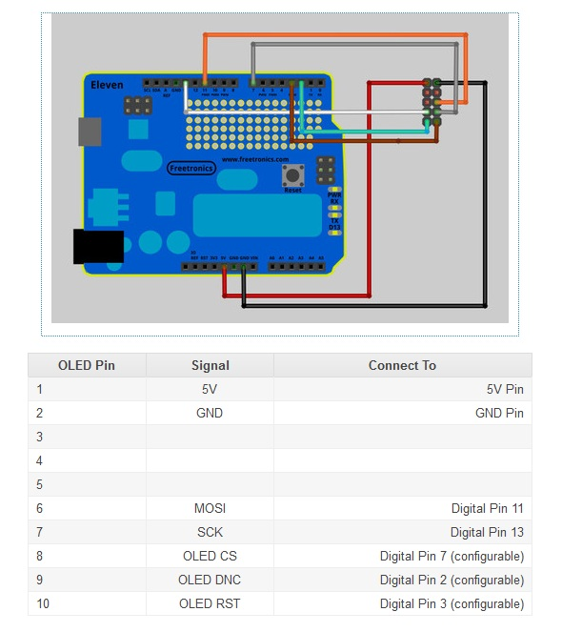

Motor Selection

VID28-05 – Dual motor dual pointer, used for fuel gauge

VID29-02 – General Workhorse

VID29-05 – Original order

VID69-02 – Clock without zero position sensor, it has a reduced gear ratio 60/1 for minute shaft and 12/1 for hour shaft. Neither of the clock based steppers will work off the generic stepper driver chip. They need a specific timing sequence to move the hands 6 degrees.

VID60-02 – Clock stepper, with zero detection (or say 12 o’clock detection) is an upgraded version based on VID69 car clock motor. Zero detection function adopted opto-mechanical system (Zero Detection function OSRAM LPT80A IR receiver) and electronics signal management.



The stepper motor driver is a VID6606 (may also be known as a UM12017), which drives 4 steppers and ships in a SOP-28 form factor.

AliExpress stores used:

<http://www.aliexpress.com/store/1046577> - original order

<http://www.aliexpress.com/store/118950> - second order

# More To dos

The pit is currently complete aside from needing wiring done. The ghosting that appeared when working with the Arduino input card was due to lack A lack of plot resistors on the bus. One of the workarounds used was the addition of diodes this really just mastered the problem it is probably not needed in future rollouts however the Jet Ranger will need to be revisited is ghosting was noted and testing.

The only way code will need to be moved from Google to get up. The code also needs to be duplicated to reflect the new Ethernet settings used by the right-hand or starboard only the mocks.

The logic for the clock and the compass is as follows. On power up both will seek to the zero position for the compass and the clock this is done by stepping back counter clockwise and then stepping forward this assumes that the device has been zeroed on shutdown if zero point is not noted then both o’clock and compass will seek the zero point anticlockwise matter.

The clock has two positions which are close to 0 so the analogue zero value may have to be adjusted another improvement that can be made is looking to see if both o’clock and the compass meet moo currently a time is set each of these which means performance is degraded when both amazing.

Another consideration is moving some of the Open Cockpits outbox notably the bank medics switch and the fire handles two and Arduino solution this will leave the “pets cards all be held to be done future simulators will just use Arduino

Other to do is include one flood lighting using lead strips there in the 737 tying the flood lighting to the switch on the electrical panel. Also the joystick moving associated with the Arduino card will need to be configured

As the stubble projector is playing up search or other available B&Q projector one consideration is to use the black projection screen from Simpits in New Zealand.

The LUA scripts on the development environment will need to be sorted and uploaded to Google code. Further documentation of the production anyway scripts should also be done

The potentiometers used in the lighting panel are too short and need to be replaced with potentiometer is of longer shafts.

The proposed in MFD design that includes the Gray-Hill rotary switch for power will need a large PCB at least three layers of 3 mm acrylic with the potential additional layer needed to support the great help switch. The PCB buttons could either be natively mounted against the switches all cut out of figure acrylic the cutting process. Will need the table slighted to ensure a right angle cut from the laser. It is suggested get a model be used or build for the bottom left in corner which has two buttons going up the left and bottom sides MFD power switch. A possible option is to use four discrete PCBs, similar to the F18s at Air Combat Center. Given this is the matrix of approximately 4 x 8 aw 2 x 16 Space should be available on the port side Arduino joystick card.

The name of your Arduino joystick card can be edited by loading the Hicks file into the Arduino bit later programmer I said search been performed for CVP note the string is encoded using UNNI encoding which means you cannot search the CBP by itself. The new name for the joystick should be the same length as the existing joystick night the file is the buffer is being saved as Hex final and then reloaded into the programmer at this point it can be programmed into the Arduino. Note if the joystick has been previously plugged in you’ll see different results between war and DirectX API calls as these names can be cashed

If wanting to use the Arduino joystick controller then you need to ensure the mega that is ordered as a DS if you programming pin as some of the Chinese supplied Arduino’s do not have those pins.

Aside from the joystick controller all a dream knows have unique IP and make addresses assigned this enables remote troubleshooting and testing kia needs to be carried out to ensure duplicate Mac and IP addresses are not seen on the same network the Arduino’s will be powered from a USB hub that is not connected to the primary flight simulator computer this means the Arduino’s operate independent of the computer and I’m not impacted by computer resets

On the printed circuit boards the first order is correct layout for joystick interfaces and then orders three and five have correct layouts for other interfaces

Future plans

DCS

Tidy up LUA scripts and examine way to sing commands similar to Ian’s code for the magnetic switches also look way of monitoring switch status via Ian’s code two Mara magnetic switch status and only seen changes as required as opposed to existing toggle actions.

Revisit I drew no code for small LCDs look at samples on YouTube and don’t forget a lot resistors.

Consider looking at the black screen for wraparound projection as per the example on the Christi site.

Verify all instruments are zeroed on LUA shutdown currently throttle and engine related instruments I’m not zero

Update LUA code so that on start-up all eyelids display port number for half a second and then permanently display recommended values or in OP on displays until the first UDP packet arrives.

Increase the cycle delay for the stepper driving the GeForce meter is this is currently dropping. Or missing steps this state is repeatable using the first cockpit driving program.

Replace normally closed it and switches with normally open eaten switches.

Also consider Allied à la Tron X is a nob sauce.

Jet Ranger

Development work on the Jet Ranger is waiting for the release of the HD Dodo. What’s that has released a full diskcopy will be made and then prepare your 3-D will be installs along with the updated or Bex scenery at this point the ghosting problem will be revisited and tested using porkies joystick testing program. The keypad interface Will be moved to the left off the collective stick in the centre. The encoders on the front panel will also be retested–Leo Bodnar cards are being used attend to replace them with the Arduino joystick input.

The market will be monitored for new high resolution compact projectors.

The 737 Project

Contact Frank and see about shipping costs associated with new seats. New sentence also discuss projector options and with the crispies were worth it.

Also validate pricing of Queens piddles compare to open cockpit piddles do want links but do need to consider height of pills and simulator

Generate table of expected and pots for the overhead panel. See if problematic outputs are available from flightdeck solutions software so that I drew nose can be used to drive both legends as well as seven segment displays. Ideally the same Arduino based approach Will be used.

Build mounting rig for overhead panel for wiring this will enable Warren to be done outside 737 Michelle. All imports or switch positions Will have closed imports both switch positions this will enable some sinker and stuff.

In grade buttons and find switches for water brake pedal explore manually building LED holders fallback lining of overhead the other option is light situation using strips but this has considerations for shadowing probably continue to use Green backlighting unless something else jumps out chick CP flight instruments in one common with those which is probably a soft white.

Verify inverters are available to drive 24 V lights

Check with Pete regarding eligibility to run new software older software has not been downloaded or activated.

Check with Frank and see if you still prefers using Interface software that he’s chosen with the radar seems to be a common factor today

Build out the SOIC interface for the auto-throttle and test.

F16

See if code is available to drive was ran lights from Arduino knows check to see if Leo users ITC bus or like this will be determined fire the number of cables required from breakout boards.

Consider building new faceplates that are the same size as mikes but this time with LEDs and using Arduino joystick imports

# Data Flows

USB I/O 1

USB I/O 2

USB I/O 3

CDU

Brydling

Leo Bodnar

Arduino

I2C Splitter

GPS

Oled 1

Oled 2..

Oled ..6

Oled 7

Dimmable

Simmeters

Gauges

|  |  |  |  |  |  |  |  |  |  |  |  |  |  |  |  |  |  |  |
| --- | --- | --- | --- | --- | --- | --- | --- | --- | --- | --- | --- | --- | --- | --- | --- | --- | --- | --- |
|  | Other Virtual Stick | |  |  |  |  |  |  |  |  |  |  |  |  |  |  |  | |
|  | Pin Label | PD7 | PG2 | PG1 | PG0 | PL7 | PL3 | PL5 | PL4 | PL3 | PL2 | PL1 | PL0 | PB3 | PB2 | PB1 | PB0 | |
|  | Pin | 38 | 39 | 40 | 41 | 42 | 43 | 44 | 45 | 46 | 47 | 48 | 49 | 50 | 51 | 52 | 53 | |
|  | Column | 0 | 1 | 2 | 3 | 4 | 5 | 6 | 7 | 8 | 9 | 10 | 11 | 12 | 13 | 14 | 15 | |
| Pin | Row |  |  |  |  |  |  |  |  |  |  |  |  |  |  |  |  | |
| 22 | 0 | UHF Radio | | | | VHF AM Radio | | | | Intercom | | | | | | Heading Course | | |
| 23 | 1 |
| 24 | 2 | 47 | | 48 |
| 25 | 3 | 63 | | 64 |
| 26 | 4 | 79 | | 80 |
| 27 | 5 | 95 | | 96 |
| 28 | 6 | Environmental | | | | 105 | 106 | 107 | Fuel | | | | | |
| 29 | 7 | 117 | 118 | 119 | 120 | Emergency | | |  | | | | | |
|  |  |  |  |  |  |  |  |  |  |  |  |  |  |  |  |  |  | |
|  |  |  |  |  |  |  |  |  |  |  |  |  |  |  |  |  |  | |
|  |  |  |  |  |  |  |  |  |  |  |  |  |  |  |  |  |  | |
|  |  | First 4 Rows are reserved for Rotary Switches | | | |  |  |  |  |  |  |  |  |  |  |  |  | |
|  |  |  |  |  |  |  |  |  |  |  |  |  |  |  |  |  |  | |
|  | Pin Label | PD7 | PG2 | PG1 | PG0 | PL7 | PL3 | PL5 | PL4 | PL3 | PL2 | PL1 | PL0 | PB3 | PB2 | PB1 | PB0 | |
|  | Pin | 38 | 39 | 40 | 41 | 42 | 43 | 44 | 45 | 46 | 47 | 48 | 49 | 50 | 51 | 52 | 53 | |
|  | Column | 0 | 1 | 2 | 3 | 4 | 5 | 6 | 7 | 8 | 9 | 10 | 11 | 12 | 13 | 14 | 15 | |
| Pin | Row |  |  |  |  |  |  |  |  |  |  |  |  |  |  |  |  | |
| 30 | 0 | 1 | 2 | 3 | 4 | 5 | 6 | 7 | 8 | 9 | 10 | 11 | 12 | 13 | 14 | 15 | 16 | |
| 31 | 1 | 17 | 18 | 19 | 20 | 21 | 22 | 23 | 24 | 25 | 26 | 27 | 28 | 29 | 30 | 31 | 32 | |
| 32 | 2 | 33 | 34 | 35 | 36 | 37 | 38 | 39 | 40 | 41 | 42 | 43 | 44 | 45 | 46 | 47 | 48 | |
| 33 | 3 | 49 | 50 | 51 | 52 | 53 | 54 | 55 | 56 | 57 | 58 | 59 | 60 | 61 | 62 | 63 | 64 | |
| 34 | 4 | 65 | 66 | 67 | 68 | 69 | 70 | 71 | 72 | 73 | 74 | 75 | 76 | 77 | 78 | 79 | 80 | |
| 35 | 5 | 81 | 82 | 83 | 84 | 85 | 86 | 87 | 88 | 89 | 90 | 91 | 92 | 93 | 94 | 95 | 96 | |
| 36 | 6 | 97 | 98 | 99 | 100 | 101 | 102 | 103 | 104 | 105 | 106 | 107 | 108 | 109 | 110 | 111 | 112 | |
| 37 | 7 | 113 | 114 | 115 | 116 | 117 | 118 | 119 | 120 | 121 | 122 | 123 | 124 | 125 | 126 | 127 | 128 | |

**Brydling as built**

|  |  |  |  |  |  |  |  |  |  |  |  |
| --- | --- | --- | --- | --- | --- | --- | --- | --- | --- | --- | --- |
|  |  | 8001 |  |  |  |  |  | 8001 |  |  |  |
|  |  |  |  |  |  | 48 |  | ANTI-SKID ON | ANTI SKID OFF | | 64 |
|  |  |  |  |  |  | 47 |  | FLAPS DOWN | FLAPS UP |  | 63 |
| 14 |  | JMR | MWS |  | 30 | 46 |  | SPEED BRAKES UP | SPEED BRAKES DOWN | | 62 |
| 13 |  | SEP | MISSLE LAUNCH | | 29 |  |  |  |  |  |  |
|  |  |  | ANCHR |  | 28 | 44 |  | CANOPY OPEN | CANOPY CLOSE | | 60 |
| 11 |  | HARS | STR PT |  | 27 | 43 |  | LANDING LIGHTS ON | LANDING LIGHTS TAXI | | 59 |
| 10 |  | EGI | TCN |  | 26 | 42 |  | GEAR UP | GEAR DOWN | | 58 |
| 09 |  | PRI | ILS |  | 25 | 41 |  | CICU ON | TGP ON |  | 57 |
| 08 |  | PTR STOW | PTR ABLE |  | 24 | 40 |  | GUNPAC ARM | GUNPAC GUNARM | | 56 |
| 07 |  | CMSC SPARE | TISL |  | 23 | 39 |  | MASTER TRAIN | MASER ARM | | 55 |
| 06 |  | LEFT FIRE BOTTLE | RIGHT FIRE BOTTLE | | 22 |  |  | STAND BY | NORM |  | 54 |
|  |  |  | EXT STORE JET | | 21 | 37 |  | DAY | NIGHT |  | 53 |
| 04 |  | FIRE LEFT ON | FIRE LEFT OFF | | 20 | 36 |  | IFCC ON | IFCC OFF |  | 52 |
| 03 |  | FIRE APU OFF | FIRE APU ON | | 19 | 35 |  | BARO | ALT SCE RADAR | | 51 |
| 02 |  | FIRE RIGHT OFF | FIRE RIGHT ON | | 18 | 34 |  | JTRS ON |  |  |  |
|  |  |  |  |  |  | 33 |  | LASER TRAIN | LASER ARM |  | 49 |

|  |  |  |  |  |  |  |  |  |  |  |  |
| --- | --- | --- | --- | --- | --- | --- | --- | --- | --- | --- | --- |
|  |  | 8001 |  |  |  |  |  | 8001 |  |  |  |
| 80 |  | TONE | TEST DISPLAY | | 96 |  | 112 | MASTER CAUTION | Do not use |  | POV |
|  |  | SQULECH | STATUS |  |  |  | 111 | CENTRE BLANK | Do not use |  | POV |
| 78 |  | OFF | LOAD |  | 94 |  | 110 | INTEN RIGHT | Do not use |  | POV |
| 77 |  | MAIN | MNL |  |  |  | 109 | INTEN LEFT | Do not use |  | POV |
| 76 |  | BOTH | PRESET |  | 92 |  | 108 | SELECT UP | SELECT DOWN | | 124 |
| 75 |  | ADF | GRD |  | 91 |  | 107 | DATA UP | DATA DOWN | | 123 |
| 74 |  | INT |  |  | 90 |  | 106 | ENT | FUNC |  | 122 |
| 73 |  | FM | VHF |  | 89 |  | 105 | POS | 3 |  | 121 |
| 72 |  | UHF | AIM |  | 88 |  | 104 | 2 | 1 |  | 120 |
| 71 |  | TX-INT | IFF |  | 87 |  | 103 | MK | BELOW MK |  | 119 |
| 70 |  | TX-FM | ILS |  | 86 |  | 102 | LTR | CLR |  | 118 |
| 69 |  | TX-VHF | TCH |  | 85 |  | 101 | 0 | SPC |  | 117 |
| 68 |  | TX-HF | HM |  |  |  | 100 | 6 | 9 |  | 116 |
| 67 |  |  | HARS NORM | | 83 |  | 99 | 5 | 8 |  | 115 |
| 66 |  | L-MFD ON | SIG LAMPS TEST | | 82 |  | 98 | 4 | 7 |  | 114 |
| 65 |  | R-MFD ON | FIRE DETECT TEST | | 81 |  | 97 | STEER + | STEER - |  | 113 |
|  |  |  |  |  |  |  |  |  |  |  |  |

|  |  |  |  |  |  |  |  |  |  |  |  |
| --- | --- | --- | --- | --- | --- | --- | --- | --- | --- | --- | --- |
|  |  | 8002 |  |  |  |  |  | 8002 |  |  |  |
| 16 |  |  | EMER FLOOD ON | | 32 | 48 |  | JTSN ON | INC |  | 64 |
| 15 |  | APU GEN PWR | L - AC GEN PWR ON | | 31 | 47 |  | MWS OFF | MWS MENU | | 63 |
| 14 |  | BATT POWER ON | R - AC GEN PWR ON | | 30 | 46 |  | AUTO | RWR SET |  | 62 |
| 13 |  | INVERTER STBY | INVERTER TEST | | 29 |  |  |  | DISP SET |  | 61 |
| 12 |  |  | NOSE ILLUM | | 28 | 44 |  | SEMI | ENTER |  | 60 |
| 11 |  | POS FLASH | POS STEADY | | 27 | 43 |  | DISP OFF | DISP MENU |  | 59 |
| 10 |  | SIG LIGHTS BRT | ANTI COLL |  | 26 | 42 |  | MAN | DEC |  | 58 |
| 9 |  | FLT INST ON | ACCEL COMP ON | | 25 | 41 |  | RWR OFF | RWR MENU |  | 57 |
| 8 |  | ILS - PWR |  |  |  | 40 |  | STBY | JMR SET |  | 56 |
| 7 |  | PITOT HEAT ON |  |  |  | 39 |  | JMR MENU | JMR OFF |  | 55 |
| 6 |  |  | PAGE - WAY PT | | 22 | 38 |  | OFF | MWS SET |  | 54 |
| 5 |  | STEER PT - MISSION | PAGE - OTHER | | 21 |  |  |  | AATR |  | 53 |
| 4 |  | STEER PT - MARK | PAGE - POSITION | | 20 |  |  |  | AA REC |  | 52 |
| 3 |  | STEER PT - FLT PLN | PAGE - STEER | | 19 |  |  |  | TR |  | 51 |
| 2 |  | CDU ON | EGI ON |  | 18 | 34 |  | XY | REC |  | 50 |
| 1 |  | STEER-UP | STEER-DOWN | | 17 | 33 |  | TEST | OFF |  | 49 |
|  |  |  |  |  |  |  |  |  |  |  |  |

|  |  |  |  |  |  |  |  |  |  |  |  |  |
| --- | --- | --- | --- | --- | --- | --- | --- | --- | --- | --- | --- | --- |
|  |  | 8002 |  |  |  |  |  |  | 8002 |  |  |  |
|  |  | EAC ON |  |  |  |  |  |  |  |  |  | POV |
| 79 |  | PRE |  |  |  |  |  |  |  |  |  | POV |
| 78 |  | MAN |  |  |  |  |  |  |  |  |  | POV |
| 77 |  | EMER-AM |  |  |  |  |  |  |  |  |  | POV |
| 76 |  | EMER-FM |  |  |  |  |  |  | R-MONITOR TEST |  |  |  |
| 75 |  | OFF | LOAD |  | 91 |  | 107 |  | L-MONITOR TEST | R-MONITOR TEST | | 123 |
| 74 |  | TR |  |  |  |  | 106 |  | R-PITCH SAS ENGAGE |  |  |  |
| 73 |  | DF | TONE |  | 89 |  | 105 |  | R-YAW SAS ENGAGE | L-PITCH SAS ENGAGE | | 121 |
|  |  | OFF |  |  |  |  | 104 |  | T/O TRIM | L-YAW SAS ENGAGE | | 120 |
|  |  | TR |  |  |  |  | 103 |  | R FILL DISABLE WING ON |  |  |  |
|  |  | DF |  |  |  |  | 102 |  | L FILL DISABLE WING ON | R FILL DISABLE MAIN ON | | 118 |
|  |  | EMER-FM |  |  |  |  | 101 |  | RCVR CLOSE | L FILL DISABLE MAIN ON | | 117 |
|  |  | EMER-AM |  |  |  |  | 100 |  | CROSS FEED ON |  | BOOST PUMP R MAIN ON | 116 |
|  |  | MAN | TONE |  |  |  | 99 |  | EXT TANKS ON |  | BOOST PUMP R WING ON | 115 |
|  |  | PRE | LOAD |  |  |  | 98 |  | TK GATE OPEN |  | BOOST PUMP L WING ON | 114 |
|  |  | Seat Arm | Eject |  |  |  | 97 |  | EXT WING ON |  | BOOST PUMP L MAIN ON | 113 |
|  |  |  |  |  |  |  |  | 103 Breaker doesn't lock properly | | |  |  |

# Data Flows with Protocol and Ports

USB I/O 1

USB I/O 2

USB I/O 3

CDU

Brydling

Leo Bodnar

Arduino

I2C Splitter

GPS

Oled 1

Oled 2..

Oled ..6

Oled 7

Dimmable

Simmeters

Gauges

TCP-8092

UDP -7777

UDP -7780

UDP -7781

UDP -7782

COM4

Memory Scan

UDP 6061

UDP -7780

SlimDX

SlimDX

COM?

DX

DX

UDP -7781

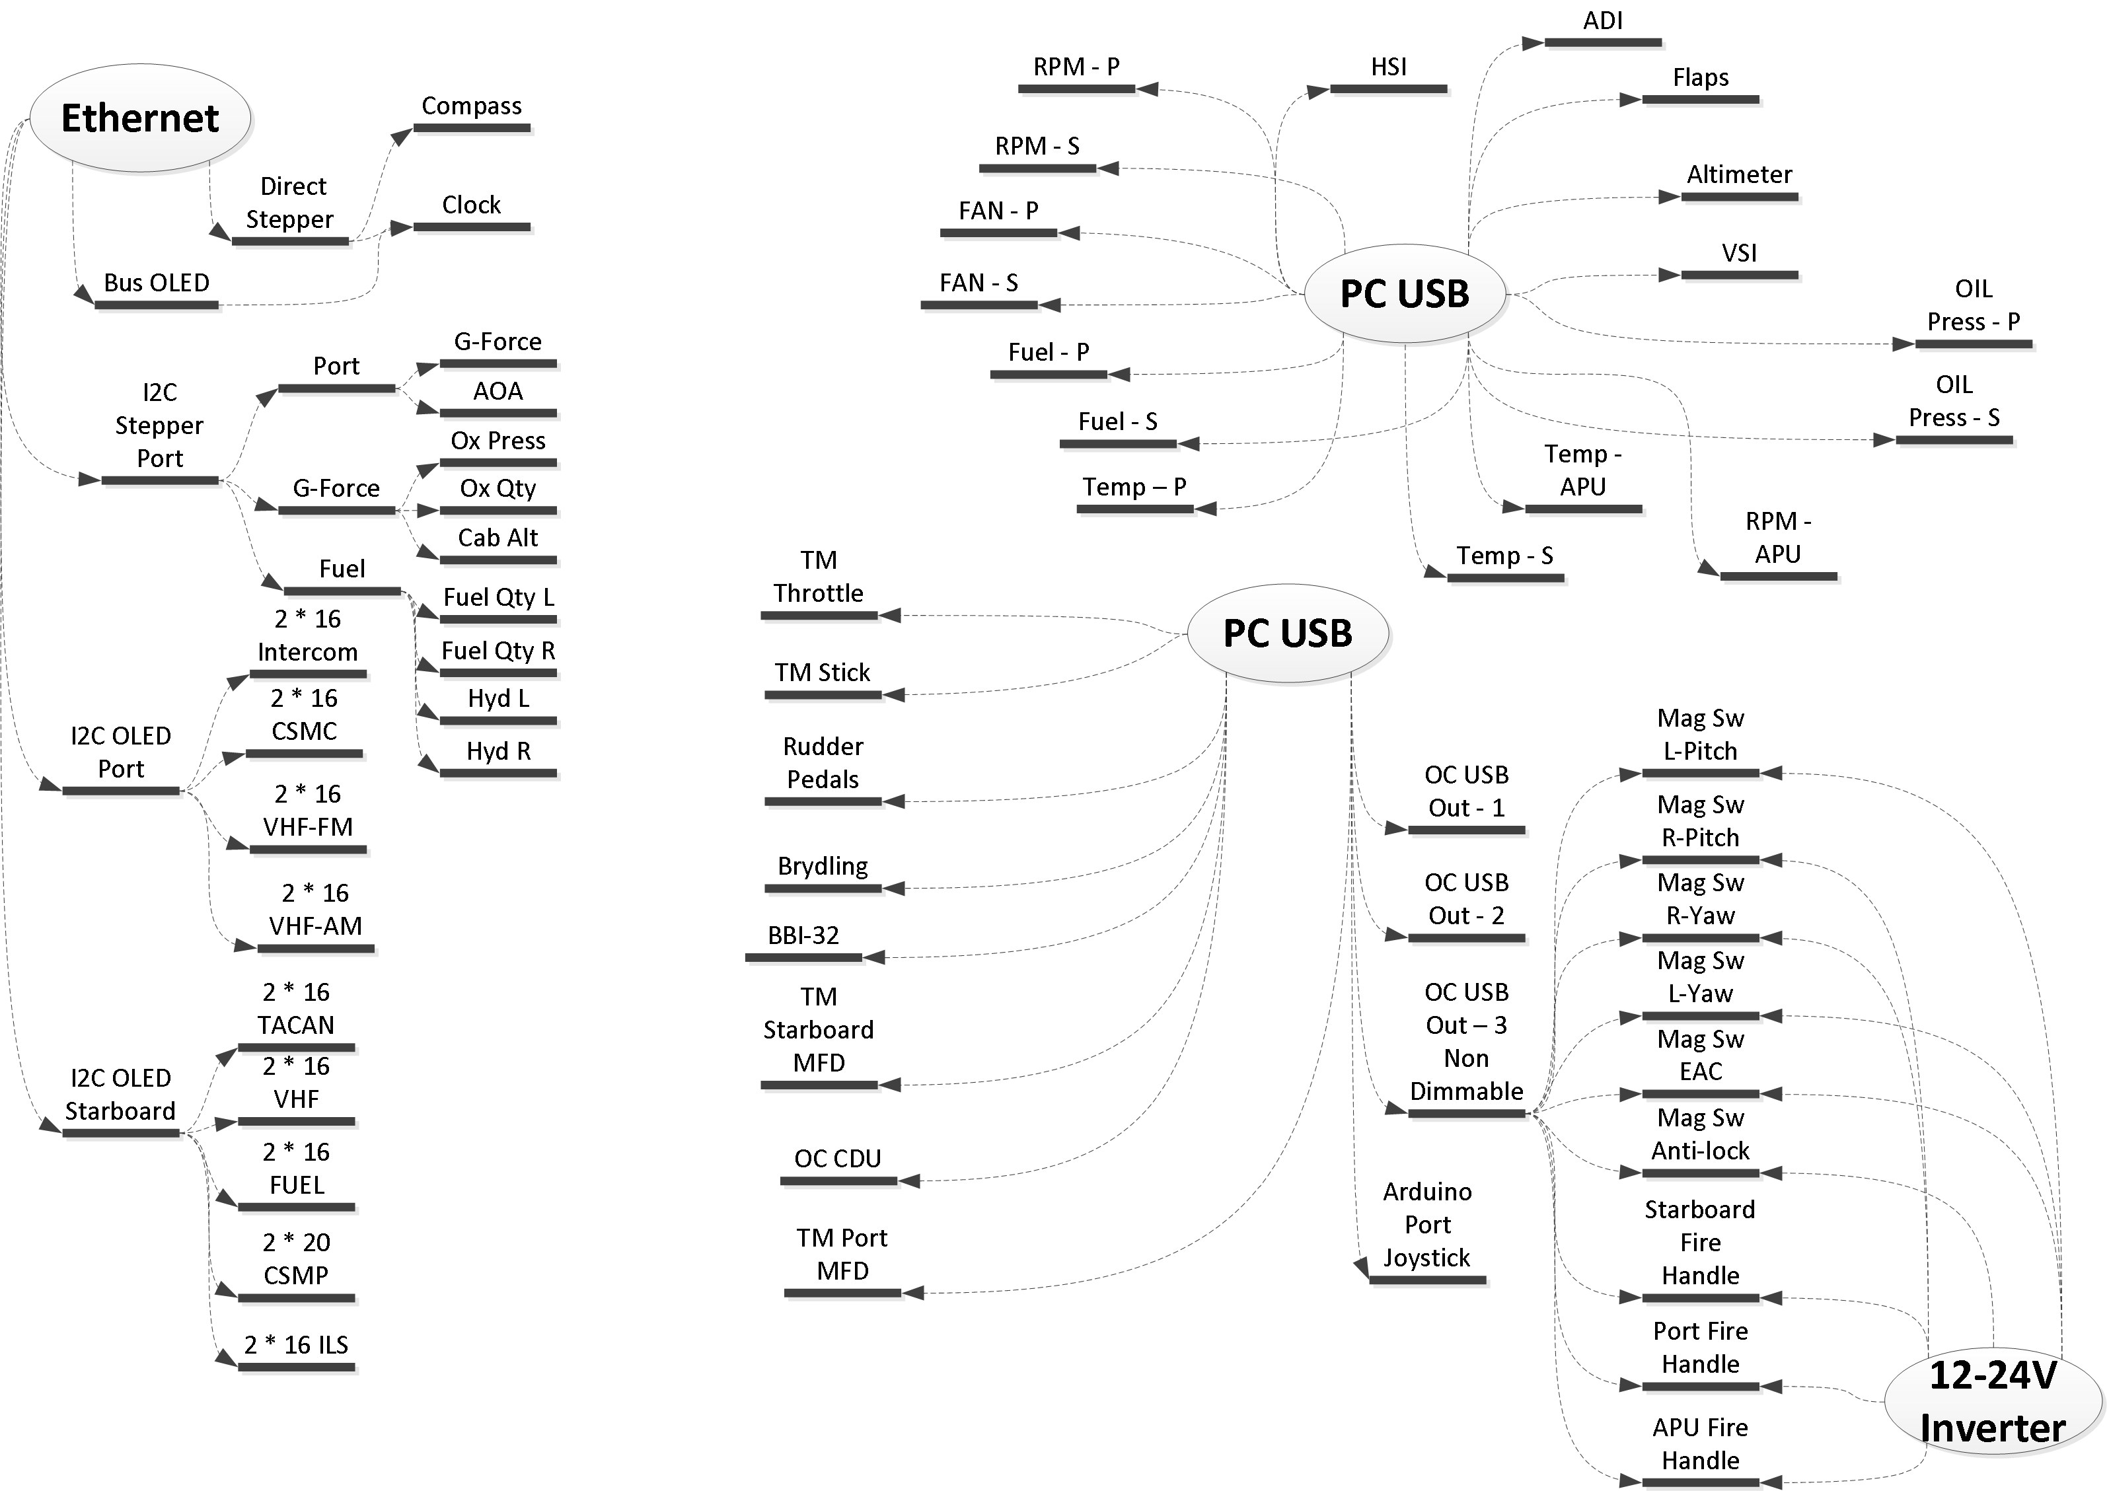

# Devices

Arduino Port Side Joystick

Leo Bodnar BBI-32

Thrustmaster

L-MFD

12V-24V

Inverter

12V LED - Relay

Fire Handle - 1

Magnetic

Switch – 1

L - Pitch

Magnetic

Switch – 2

R - Pitch

Magnetic

Switch – 3

L - Yaw

Magnetic

Switch – 6

EAC

Magnetic

Switch – 5

Anti-Lock

Magnetic

Switch – 4

R - Yaw

Fire Handle - 2

Fire Handle - 3

Landing Gear Light - 1

Engine Cluster

Altimeter

VSI

ADI

HSI

Flaps

OC CDU

OC USB Output -3

OC USB Output -2

Arduino Stepper

Rudder Pedals

Thrustmaster

Warthog

Thrustmaster

R-MFD

Stepper Chip

Direct Drive with Zero Pos Sense

Environmental

OC USB Output -1

Non-Dimmable

Back-lighting

Control - A

Compass

Fuel

Clock

G-Force, AOA

Brydling

Flood-lighting

Control - A

Arduino Display

2 * 16 OLED

VHF FM

2 * 20 OLED

CSMP

Clock OLED

Bus

I2C Demux

2 * 16 OLED

CSMC

2 * 16 OLED

TACAN

I2C Demux

2 * 16 OLED

VHF-AM

2 * 16 OLED

UHF

2 * 16 OLED

ILS

2 * 16 FUEL

I2C Demux Schematic –

1K resistors used as leds only needed for status indication. To export as jpg, preview, then save, 300 dpi min

# 

# Stepper Motor for Compass and Clock

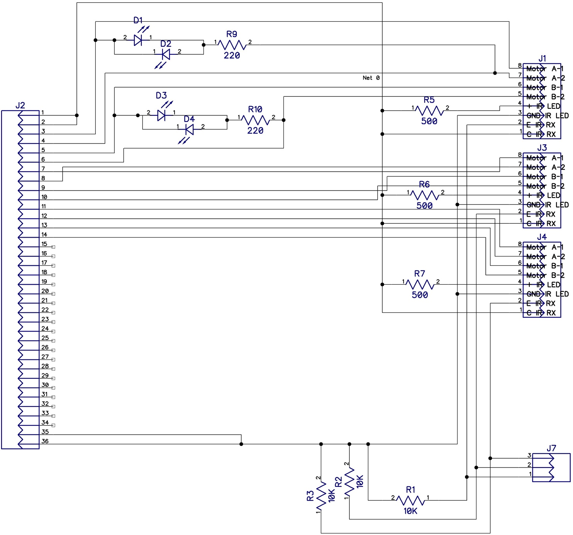J7 connects to the analog inputs on the same board.

Only the first stepper has indicator Leds, this is largely to save real estate, and indicator leds are normally only used for troubleshooting.

# Stepper Motor with Vid

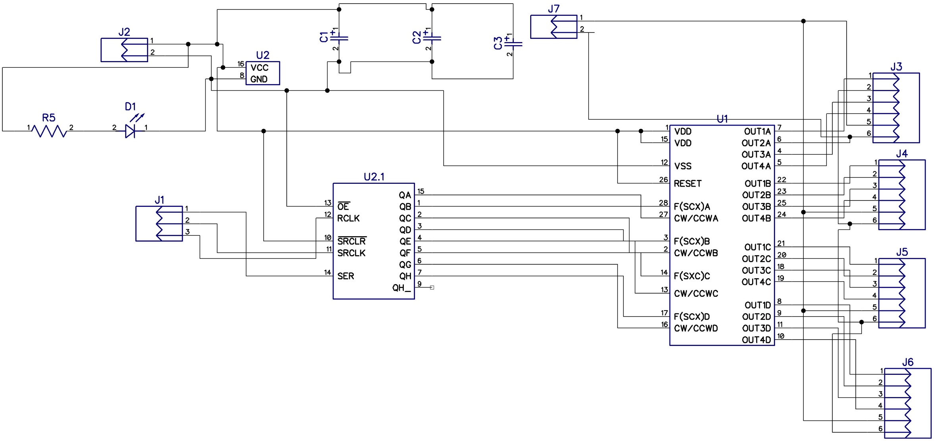

# Joystick Input Card

Added pull up resistor array to remove ghosting.

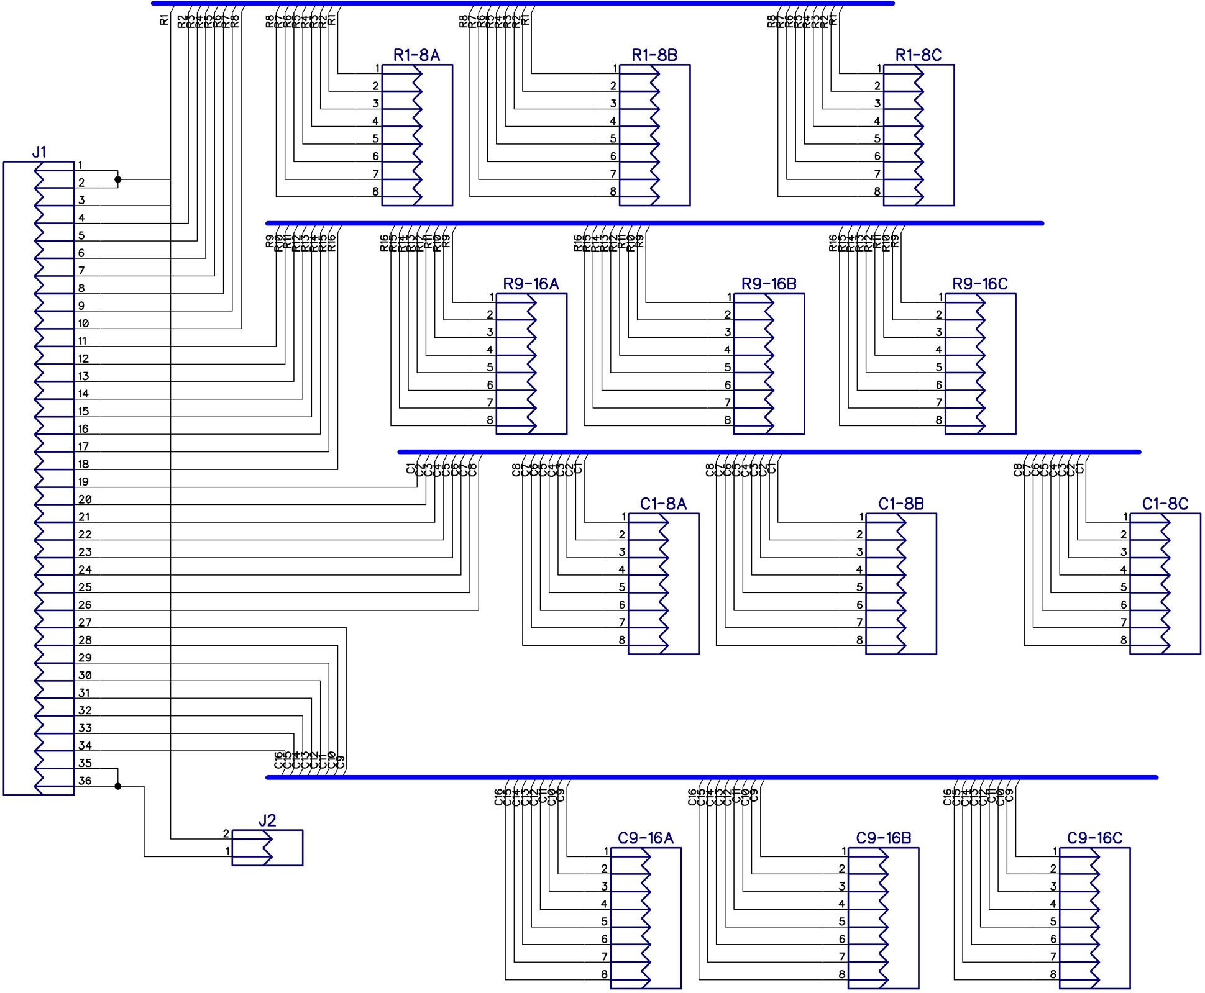

# PCB Layouts

# V6 PCB –

note that U2 has been shifted to the right to allow for space of Ethernet header.

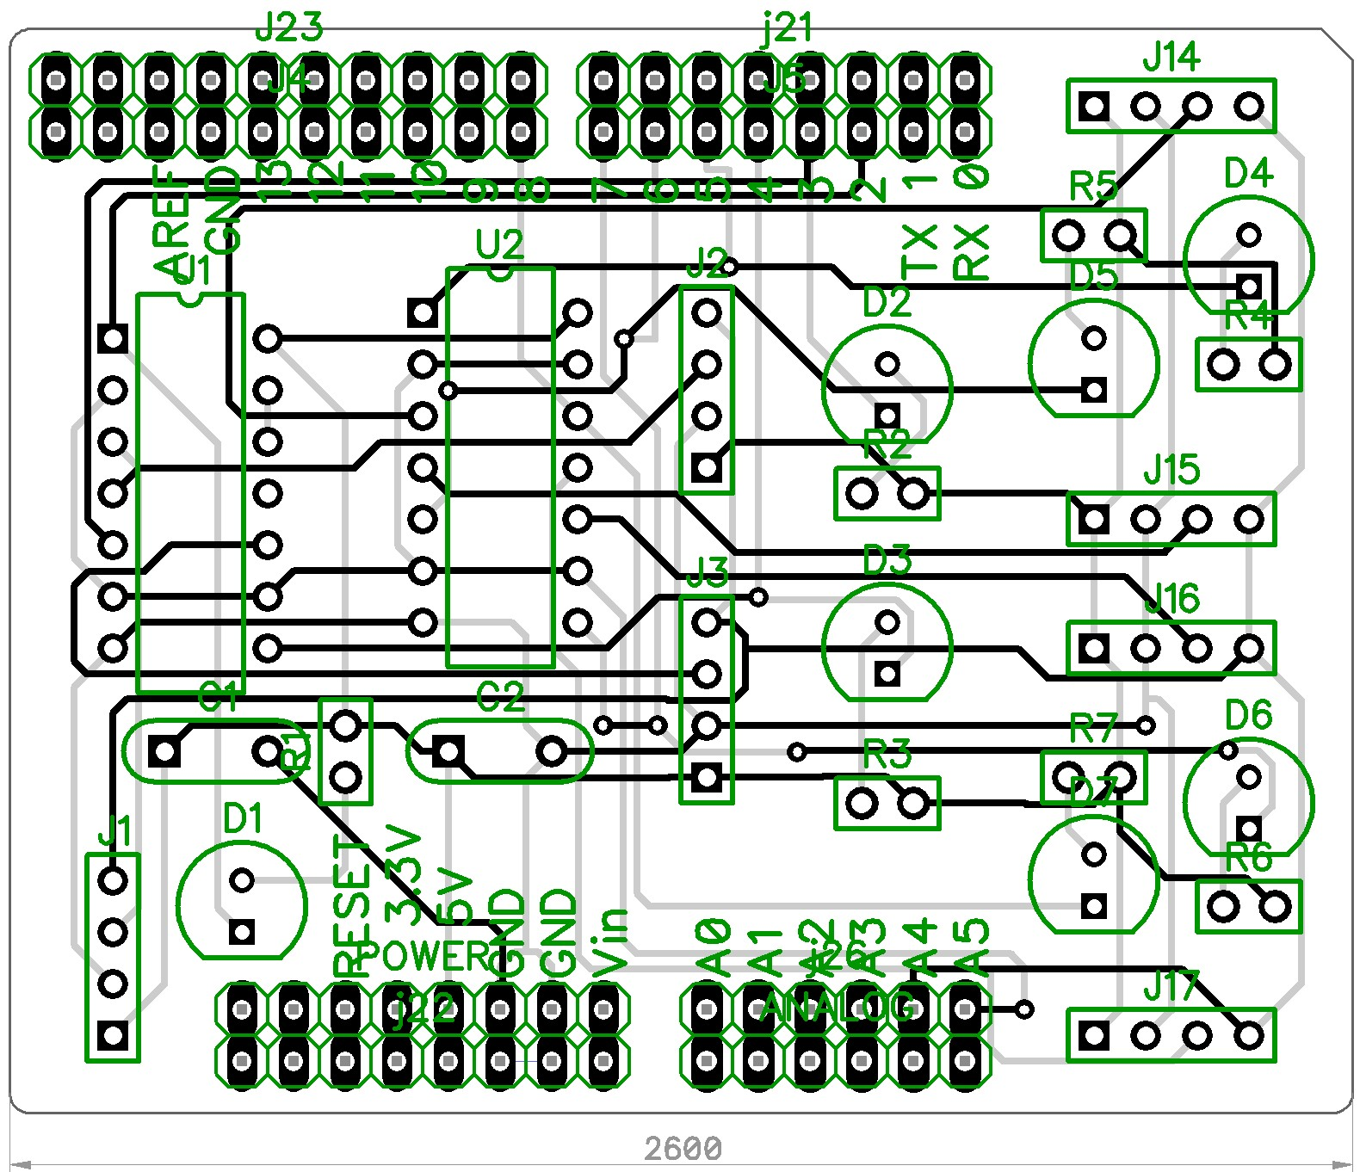

# Previous version

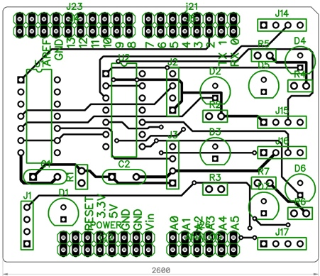

# Order 3

# 

# Order 1

Note errors in Stepper and bottom left layouts. Joystick mapping ok.

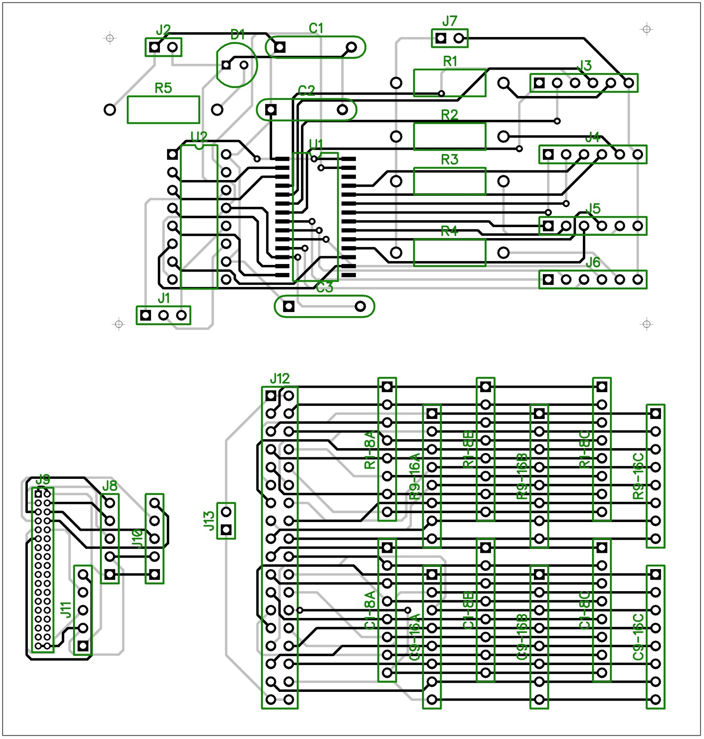

# OLED128 QuickStart Guide

The [Freetronics OLED128 is a 128x128 pixel full colour 1.5" OLED display module](http://www.freetronics.com/products/128x128-pixel-oled-module), with an Arduino-compatible interface. The FTOLED library enables graphics display on the OLED128.

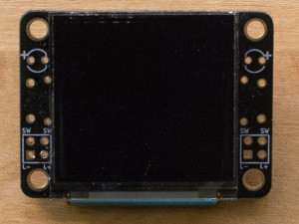

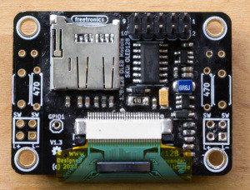

The OLED128 also features an onboard MicroSD card slot that can be used to store graphics or other data.

In this guide we’ll show how to connect the OLED128 to your board, and how to install the FTOLED library into the Arduino IDE.

# Connecting the OLED128

**IMPORTANT:** If you're using either the [OLED Shield](http://www.freetronics.com/oledshield) or [OLED Stick](http://www.freetronics.com/oledstick) adapter board with your OLED128, you should follow the directions in the [OLED Shield QuickStart guide](http://www.freetronics.com/pages/oled-shield-quickstart) or the [OLED Stick QuickStart guide](http://www.freetronics.com/pages/oled-stick-quickstart).

On the back of the OLED128 you’ll see there’s a 10 pin header, with numbers printed to indicate pins 1 & 2:

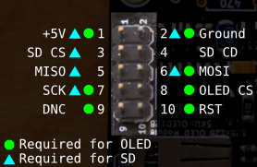

Start by wiring up the connections marked as "Required for OLED":

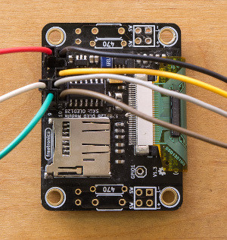

And then connecting them to an Arduino-compatible board

## Alternative Connections

The above example uses the 6-pin ICSP header to connect two SPI pins (MOSI, SCK) and also 5V and Ground. However some Arduino-compatible boards have the same SPI functionality on other pins.

Alternative wiring for Uno-compatibles (Atmega328p or Atmega168p):

[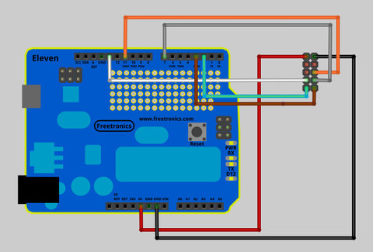](http://cdn.shopify.com/s/files/1/0045/8932/files/oled128-10-fullsize.jpg?828)

| **OLED Pin** | **Signal** | **Connect To** |
| --- | --- | --- |
| 1 | 5V | 5V Pin |
| 2 | GND | GND Pin |
| 3 |  |  |
| 4 |  |  |
| 5 |  |  |
| 6 | MOSI | Digital Pin 11 |
| 7 | SCK | Digital Pin 13 |
| 8 | OLED CS | Digital Pin 7 (configurable) |
| 9 | OLED DNC | Digital Pin 2 (configurable) |
| 10 | OLED RST | Digital Pin 3 (configurable) |

Alternative wiring for Freetronics EtherMega or other Mega-compatible:

| **OLED Pin** | **Signal** | **Connect To** |
| --- | --- | --- |
| 1 | 5V | 5V Pin |
| 2 | GND | GND Pin |
| 3 |  |  |
| 4 |  |  |
| 5 |  |  |
| 6 | MOSI | Digital Pin 51 |
| 7 | SCK | Digital Pin 52 |
| 8 | OLED CS | Digital Pin 7 (configurable) |
| 9 | OLED DNC | Digital Pin 2 (configurable) |
| 10 | OLED RST | Digital Pin 3 (configurable) |

On an Arduino Due, LeoStick, or other Leonardo-compatible board the only SPI pins are on the 6-pin ICSP header, so these are the ones you must connect in order to use the OLED128.

Note that digital pins 2,3 & 7 are used by default in the FTOLED examples. However these pins are configurable, you can use any non-SPI digital pins for these if you edit the sketch before uploading. This means on an Eleven or other Uno compatible you can use any pins but 11-13. On EtherMega & other Mega compatibles you can use any pins but 50-52. We recommend using 2,3 & 7 if you can.

 Connecting the MicroSD Card Slot

To use the MicroSD card slot as well as the OLED display, two additional wires need to be connected from pins 3 & 5 on the OLED connector:

[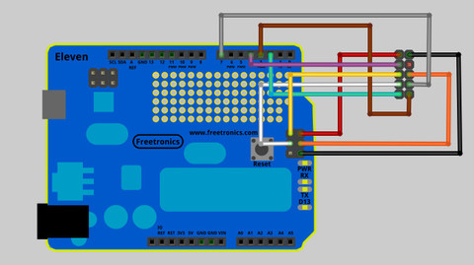](http://cdn.shopify.com/s/files/1/0045/8932/files/oled128-12-fullsize.jpg?832)

| **OLED Pin** | **Signal** | **Connect To** |
| --- | --- | --- |
| 1 | 5V | ICSP 2 or 5V Pin |
| 2 | GND | ICSP 6 or GND Pin |
| 3 | SD CS | Digital Pin 4 (configurable) |
| 4 | SD CD | Can leave unconnected |
| 5 | MISO | ICSP 1 |
| 6 | MOSI | ICSP 4 |
| 7 | SCK | ICSP 3 |
| 8 | OLED CS | Digital Pin 7 (configurable) |
| 9 | OLED DNC | Digital Pin 2 (configurable) |
| 10 | OLED RST | Digital Pin 3 (configurable) |

## Note about cabling

SD cards can be quite selective about cable quality. Try to use good quality low impedance cable, avoid unnecessary junctions. We recommend keeping the overall cable length to no more than 15cm.  
  
(On the other hand, the OLED display itself is quite forgiving when it comes to cable quality - 75cm or longer is no problem to just display graphics.)

## SD CD (Card Detect)

Pin 4 on the OLED128 connector (“Card Detect” from the MicroSD slot) doesn’t need to be connected.

This pin is a switch which closes to ground if a card is present. However the [Arduino SD library](http://arduino.cc/en/Reference/SD) doesn’t require this pin.

## Alternative MicroSD Connections

On a Freetronics Eleven or other Uno-compatible, you can choose Digital Pin 12 intead of ICSP pin 1 for the MISO signal (OLED pin 5.)

On a Freetronics EtherMega or other Mega-compatible, you can choose Digital Pin 50 instead of ICSP pin 1 for the MISO signal (OLED pin 5.)

# 

# Installing the FTOLED Library

The [FTOLED library](https://github.com/freetronics/FTOLED) is used for communicating with the OLED128 display from the Arduino IDE. You can [download the FTOLED library as a zip file](https://github.com/freetronics/FTOLED/archive/master.zip).

The zip file will be called “FOLED-master.zip”. When you unzip it, rename the directory from “FTOLED-master” to “FTOLED”.

Place the FTOLED directory inside your Arduino libraries directory. Your libraries directory is usually inside your Arduino “sketchbook” directory, which is usually a directory called “Arduino” inside your documents directory.

If you’re not sure where your sketchbook directory is, you can check (or customise it) under File -> Preferences in the Arduino IDE.

Once you’ve placed the FTOLED library directory in place, the structure should look something like Arduino -> libraries -> FTOLED.

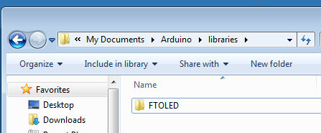

After you restart the Arduino IDE, the FTOLED example sketches will be available under File -> Examples -> FTOLED

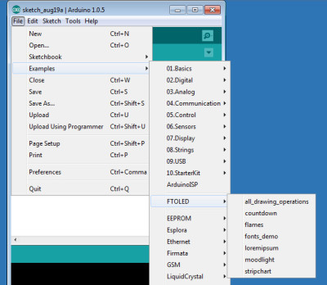

# Uploading your first OLED Sketch

The first sketch is called “all_drawing_operations” and uses all of the basic drawing commands available in FTOLED.

If you choose this sketch under File -> Examples -> FTOLED and upload it, you should see the simple drawing pattern on the OLED128:

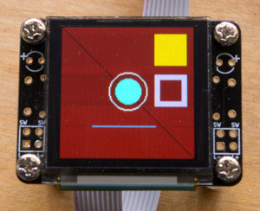

(Remember to change pin assignments at the top of the sketch if you haven’t used digital pins 2,3 & 7 when wiring up!)

The horizontal bands visible in this demo are caused by the solid colour background. Most demos of small OLED displays use black backgrounds, and this is why.

# Exploring the Examples

Have an experiment with the rest of the example sketches. A few of the sketches (like Flames) require you to also load some files onto the MicroSD card. There’s a comment at the top of the sketch that explains this. The files can be found inside the FTOLED Library directory, under Examples.

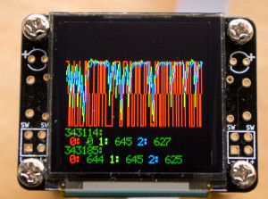

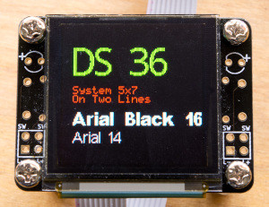

# Using the FTOLED Library

You can find the full documentation for the FTOLED Library [here on the FTOLED Wiki](https://github.com/freetronics/FTOLED/wiki/Using-FTOLED).

## Snap Off Tabs

The two “wings” on the OLED128 board are designed to be snapped off if you want a more slimline look for your OLED128.

# Mounting buttons and LEDs on the wings

Each “wing” on the side of the OLED128 allows you to solder on one pushbutton and one 3mm LED plus a current limiting resistor. The pushbuttons are supplied with the OLED128.

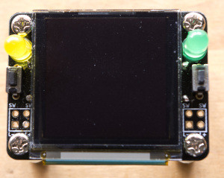

When soldering these on, we suggest mounting the resistor underneath the display (where there’s more room), and soldering it first. Then solder the pushbutton and the LED.

The four contacts on the bottom of the wing are marked SW,SW,L+ and L-.

Th two SW contacts are connected to either side of the switch, L+ and L- to the positive and negative sides of the LED with resistor.

These optional features are not connected to the main OLED128 module or the 10-pin OLED128 connector, you need to wire them back yourself.

# Beware Burn-In

If you expect the OLED128 to be left on for a long time (a day or longer), try to avoid leaving the same pattern displayed on the screen for a long time.

The phosphours in the display will wear out unevenly, and you can be left with a pale “ghost” of the long-term image caused by burn-in. This is the same problem that effected old CRT monitors, and it effects [OLED televisions as well](http://www.lg.com/ca_en/oled/whats-oledtv.jsp).

To avoid burn-in:

* Move the image displayed on the screen around regularly. Change the screen layout regularly.
* Build in “screensaver” functionality to put the screen to sleep if it’s idle for a long time.

# OverPros Joystick

From <http://forums.eagle.ru/showthread.php?t=117011>

This is an arduino Mega2560R3 based USB joystick controller,   
I have successfully made it as a composite USB device ,   
that means one arduino = two usb joystick controller, the reason to do this is DCSW only recognize 128 keys per USB joystick controller. If we have 2 then there will be 256 keys   
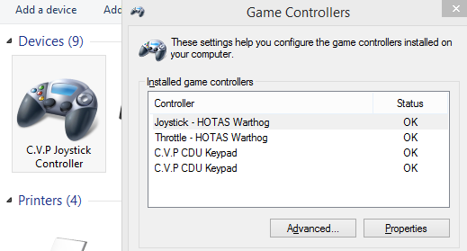  
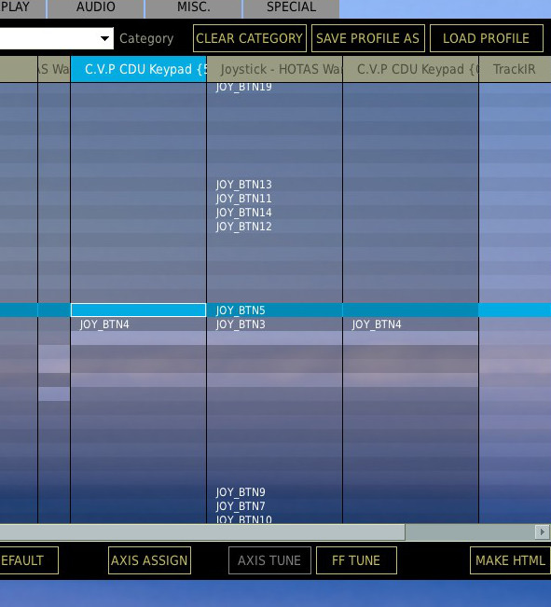  
  
  
**program your Mega2560**  
download Arduino IDE from arduino.cc and download the arduino sketch from here:

Code:

https://github.com/calltherain/ArduinoUSBJoystick/tree/master/arduino

open the .ino file in Arduino IDE and upload it to your mega2560.  
  
**program the USB firmware**  
The 2nd step is to program the USB firmware, you need to use Atmel Flip:  
<http://www.atmel.com/tools/FLIP.aspx>  
  
Download and install flip, you need to make your Mega2560 enter DFU mode: with your mega2560 plugged, just simply **shortcut the 2 pins momentarily** at here:   
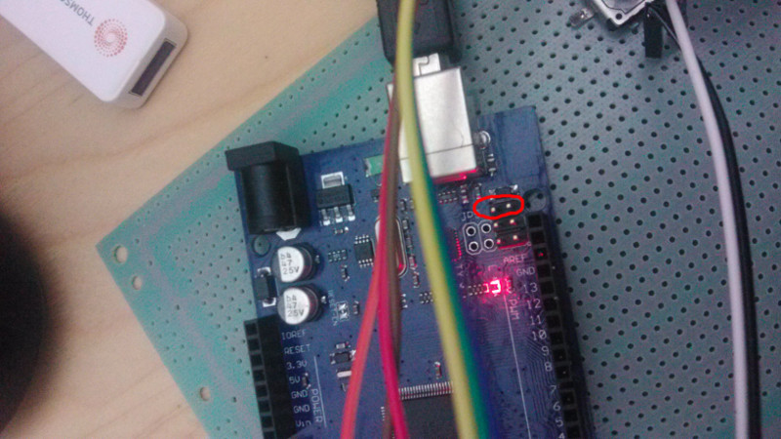  
Windows will recognize it as a new device, and you need to manually install the driver by using this file:  
C:\Program Files (x86)\Atmel\Flip 3.4.7\usb\atmel_usb_dfu.inf  
  
After the driver is installed, run Flip and select the chip type: ATmega16u2  
then Open the USB port ( ctrl + u, click OPEN ) and load the usb controller firmware, see attached cvpJoystick YYYY-MMM-DD.zip file.  
  
  
Click "RUN" button at the lower left corner and it only takes 1 second to program the chip.  
Unplug and replug your mega2560 and you are good to go.  
  
If you want to make it back to a normal Mega2560 then repeat the above step but load the original mega2560 USBSerial firmware from here:  
[https://github.com/arduino/Arduino/t...uino-usbserial](https://github.com/arduino/Arduino/tree/master/hardware/arduino/firmwares/atmegaxxu2/arduino-usbserial)  
Arduino-usbserial-atmega16u2-Mega2560-Rev3.hex  
  
**Pin config on Mega2560**  
Pin 22~37 are row pins and 38~53 are column pins, you might need to build a keyboard matrix by your self, Row 0~3( pin 22,23,24,25) is reserved for rotary encoder, you need to wire the common pin of the rotary encoder to mega2560 22~25, and wire the A, B pin on the encoder to 0,1 or 2,3 or 4,5 ..... column pins ( mega2560 38,39 or 40,41 ..... )  
  
[**Known Issue**](http://forums.eagle.ru/showpost.php?p=1934885&postcount=5)  
The firmware might have some issue and if you encounter any problem please provide your comments on github or at this thread.  
github.com/calltherain/ArduinoUSBJoystick  
[http://forums.eagle.ru/showpost.php?...85&postcount=5](http://forums.eagle.ru/showpost.php?p=1934885&postcount=5)  
If you want to build the firmware by yourself you need a Linux machine.  
  
**License**  
The code is released to Public Domain  
  
**Source Code**  
<https://github.com/calltherain/ArduinoUSBJoystick>  
I hope you enjoy it.  
  
ps. this firmware is inspired by Darran's project: Arduino UNO Big joystick HID firmware: <http://hunt.net.nz/users/darran/weblog/15f92/>   
with out Darran's code I will never make this work. Thanks Darran.  
  
  
**---------------------------------  
Firmware compilation instruction  
---------------------------------**  
  
This is a simple instruction to guide you compile the firmware in ubuntu.  
  
1. Make sure you have these packages installed on Ubuntu

Code:

avr-libc c-compiler make

you can use this command to install these packages:

Code:

apt-get install avr-libc c-compiler make

2. download the firmware source code from github

Code:

cd ~ git clone https://github.com/calltherain/ArduinoUSBJoystick.git

3. download LUFA library

Code:

cd ~/ArduinoUSBJoystick wget https://lufa-lib.googlecode.com/files/LUFA-130901.zip unzip LUFA-130901.zip -d LUFA

4. by the end of step 3, you should get a folder structure like this:  
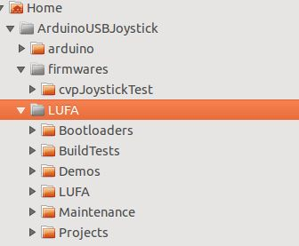  
  
now go to /ArduinoUSBJoystick/firmware/cvpJoystickTest/ and execute

Code:

make

the compiled binary is cvpJoystick.hex, you can use FLIP to flash it into your Mega2560's atmega16u2 chip under it's DFU mode.  
  
  
---------------------------------------------  
Flash the original firmware to your Atmega16u2  
---------------------------------------------  
  
If you are unable to go to DFU mode it's possible that the firmware within your Atmega16u2 doesn't have a proper bootloader code within bootloader section in the flash.   
  
You will need an USB ISP programmer to flash a correct firmware.   
  
I attached a working version firmware (atmega16u2.zip) which includes a proper bootloader here just incase you can't find one.   
  
connect your USB ISP programmer to the atmega16u2 ISP pins, you might need some Dupont Line to do this.  
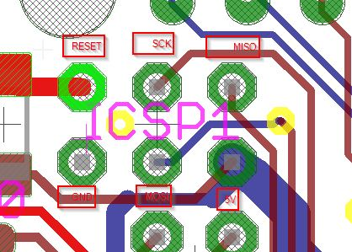  
  
There are many ISP programmer software available out there, I personally use Progisp.exe, downlod atmega16u2.zip and extract it to .hex file, load it into progisp.exe and flash it, all done.

1. http://forums.eagle.ru/showpost.php?p=2222974&postcount=37